Tuesday, 13 December 2022
36:05 Volume 36 Number 5
Published by WWII History Round Table
Written by Dr. Joe Fitzharris
www.mn-ww2roundtable.org
Welcome to the December session of the Dr. Harold C. Deutsch World War II History Round Table. Tonight's speakers, Lois Lembo and Leon Reed, will discuss their book, A Combat Engineer with PATTON’S ARMY. Lembo’s father served in the 305th Combat Engineer Battalion of the 80th Infantry Division and tonight’s talk focuses on Patton’s Combat Engineers in Europe.
The term “combat engineers” includes many different kinds of units doing different functions and soldiers from many different Military Occupational Specialties. Their common location is in the “Combat Zone” rather than the “Communications Zone.” (See illustration.) Military units have had engineers since at least the “Immunes” of the Roman Legions who doubled as artillerists in combat. Across time and ethnic groups, combat engineers have “dug,” creating defensive positions, erecting or removing obstacles and barriers, repaired and replaced bridges and roads, and built or repaired buildings for use by their troops, often working while under attack. They also fought.
In World War II, combat engineers built prisoner of war (PW) enclosures, airstrips and airfields and “put the road back where it belonged” - tracked vehicles really destroy dirt roads. The dust or mud needs to be returned to the roadway because repaired and constructed roads are avenues of advance. Removing or installing mines (anti-vehicle and antipersonnel) in areas previously held by the enemy was very risky and time-consuming. They created observation posts, command posts, gun and tank positions, and dug trenches to shelter the troops. Engineers installed and occasionally replaced temporary Bailey, ponton, treadway, and other bridges. They conducted both combat and engineer reconnaissance (the latter is searching out building supplies like I-beams, concrete or asphalt plants, lumber yards, etc.). They normally worked within range of enemy guns and often worked under fire. Their focus was on serving the needs of the combat infantry, armor, and reconnaissance troops.
Combat engineer units like the 305th Combat Engineer Battalion (CEB) did all these things working with the infantry. A CEB was part an integral part of each infantry division. Other armored or airborne battalions accompanied those specialized combat formations. Aviation engineers built forward airfields and moved close behind the line of contact from one planned field to another planned location. Other units were most specialized, like engineer dump truck or treadway bridge companies, water supply or topographic map production companies, and so on. Carpenters, welders, masons and brick layers, iron workers, water works specialists, concrete workers, clerks, draftsmen, printers, drivers, mechanics, heavy equipment operators, managers, and even engineers served in these varied units. All these units and personnel had to be combat capable.
Unfortunately, by the time the planners began assigning units to Patton’s future Third US Army, they were running out of CEBs. Rather than constituting new CEBs, they reassigned three Engineer General Service Regiments (EGSRs) to serve as combat engineers in the Third’s combat zone. EGSRs normally served in the continental US, in base areas like England, or in the Communications Zone, though they might be found working in the intermediate zone. In the segregated army, black EGSRs had the same training and served mostly as labor pools while white EGSRs did all sorts of engineering work. They built durable roads, permanent bridges, big PW enclosures, headquarters and hospitals, and other projects that were not done in the combat zone. EGSRs focused on construction, so what did combat EGSRs do?
The three EGSRs assigned to Patton’s Third US Army (3 USA), one allocated to each corps, had all their normal training and Table of Equipment and were also trained in building as well as removing temporary bridges, mining and de-mining, and fighting as infantry, all the CEB jobs. They did not have enough heavy equipment for either job and had too few vehicles to provide adequate “lift” (ability to move the entire unit at one time). The needed equipment was drawn from specialty units like the black 764th engineer dump truck company, whose section attached to Co. B of the 1303rd were effectively integrated into that company.
Based on the experiences of the 1303rd EGSR, one of three (1301 and 1306) EGSRs trained at Camp Ellis, Indiana, in 1943-early 1944, when Patton’s engineer units “found” needed equipment unattended, they “borrowed” it, painting their unit markings on the bumpers.
Elements of 3 USA entered combat on 25 July 1944 in the breakout of OPERATION COBRA and 3 USA officially became operational on 1 August, Patton officially remained commander of the fictitious First Army Group until mid-August to preserve OPERATON FORTITUDE’s Calais landing deception.
The 1303rd EGSR arrived on Utah beach on 24 July after spending three months building airfields, sand tables, and other facilities in England. On 6 August, after a month in England, the 305th CEB also landed at Utah beach. The next day the German Seventh Army began Operation Lüttich, their attempt to drive an armored spearhead through the 3 USA column moving down the lone road from Coutance to Avranches to split the force and defeated them in detail. The 1303rd deployed as infantry but saw no fighting as the 35th Infantry Division held the Germans. During this entire movement, the 1303rd and other engineer units maintained the road, removed obstacles and destroyed vehicles, and repaired bridges.
First US Army’s breakout from Normandy was successful, allowing 3 USA to turn east from Avranches and began the dash across France. The 305th moved to the tip of the spear as part of the 80th Infantry Division and the 1303rd operated slightly behind the tip, assigned to (owned by) 3 USA and attached (leased) to XII Corps and found themselves replacing Baileys with timber trestle bridges, often under fire, and building bridges using the piles of rubble the Germans left as piers. Both units built bridges in rivers at or above flood stage in the winter of 1944-1945, and both units pivoted north as Patton raced to rescue forces trapped at Bastogne. In both movements, the 1303rd was the right flank guard of 3 USA. Entering Germany, the 305th finished its war service in Austria and awaited return to the US. The 1303rd and its two sister units sailed from Camp Lucky Strike and Marseilles on 23 June aboard the USS General Pope, a fast army transport, arriving in Luzon in the Philippines to prepare for the November 1945 invasion of Japan.
FURTHER READINGS:
Lois Lembo and Leon Reed, A Combat Engineer with Patton’s Army: The Fight Across Europe with the 80th “Blue Ridge” Division in World War II (El Dorado Hills, CA: Savas Beatie, 2020).
Joseph C. Fitzharris, ed., Patton’s Fighting Bridge Builders: Company B of the 1303rd Engineer General Service Regiment (College Station, TX: Texas A&M University Press, 2007).
Robert L. Thalhofer, Company A!: Combat Engineers Remember World War II, (Bloomington, IN: Xlibris Corp., 2010).
Barry W. Fowler, ed., Builders and Fighters: U.S. Army Engineers in World War II, (Ft. Belvoir, VA: Office of History, U.S. Army Corps of Engineers, 1992).
Alfred M. Beck, Second World War: U.S. Army Engineers in Europe (Alexandria, VA: Office of History, U.S. Army Corps of Engineers, 2014).
Paul M. Kennedy, Engineers of Victory: Problem Solvers Who Turned the Tide in the Second World War Toronto: HarperCollins Pub., 2013).
Announcements:
Twin Cities Civil War Round Table – 20 Dec. 2022 – Women and the Civil War Home Front – www.tccwrt.com - info@tccwrt.com
St. Croix Valley Civil War Round Table – No meeting till 2023 – 715-386-1268 - rossandhaines@comcast.net
Minnesota Military Museum, Camp Ripley, 15000 Hwy 115, Little Falls, MN 56345 - 320-616-6050 - http://www.mnmilitarymuseum.org/
Minnesota Air Guard Museum - 612-713-2523 - www.mnangmuseum.org
8th AF Historical Society of MN, KC Hall Bloomington, 2nd & 4th Wednesdays at 1130 - https://www.8thmn.org.
Friends of Ft. Snelling - www.fortsnelling.org
World Without Genocide - 651-695-7621 - http://www.worldwithoutgenocide.org/
Fagen Fighters WWII Museum, Granite Falls, MN - Air show – TBA - 320-564-6644 - http://www.fagenfighterswwiimuseum.org.
Wings of the North Airshow - Eden Prairie – 22-23 July 2023 - Flying Cloud Airport - 952-746-6100 - www.wotn.org
Alliance Française 612-332-0436 - www.afmsp.org
Selim Center for Lifelong Learning, UST, https://www.stthomas.edu/selimcenter/
Western Naval Historical Association
info@wnha.net
Honor Flight - Jerry Kyser - 651-338-2717 - crazyjerry45@hotmail.com
CAF - Commemorative Air Force - 651-455-6942 -www.cafmn.org
We need volunteers to drive our veterans to and from meetings. Please contact Don Patton at cell 612-867-5144 or coldpatton@yahoo.com
Round Table Schedule 2022–2023
2023
10 Jan. Hitler & Stalin Collaborate
14 Feb. Marshall and Stimson
14 Mar. Navies of World War II
28 Mar. Patton & Victory in North Africa
11 Apr. New Guinea – Buna
9 May 8th Air Force in Europe
The Round Table is a 501.c.3 non-profit.
We would greatly appreciate your
supporting the HCDWW2RT.

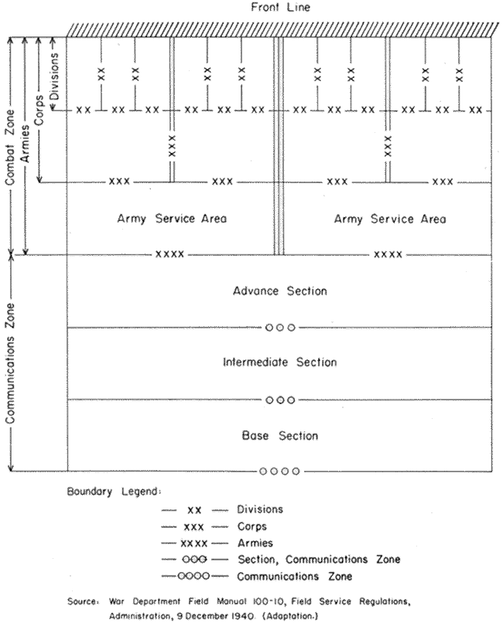
1940 US War Dept. Concept of Theater of Operations

