Thursday, 8 Mar. 2018
31:08 Volume 31 Number 8
Published by WW II History Round Table
Written by Drs. Connie Harris & Christopher Simer
www.mn-ww2roundtable.org
Welcome to the first March session of the Dr. Harold C. Deutsch World War II History Round Table. Tonight’s speaker is Conrad Crane, Chief of Historical services at the US Army Heritage and Education Center, US Army War College, and the author of American Airpower Strategy in World War II. He is joined by veterans of air operations to discuss the strategy and the personal experiences that contributed to an Allied victory in World War II.

Many technological innovations were first employed during World War I, and one, the use of the airplane, really complicated military planning throughout the inter-war years. Military aviation issues ran the spectrum from tactical support to strategic bombing — some thought (hoped) airplanes would make land armies and surface fleet navies obsolete. Airpower theorists believed that military aviation would change dramatically warfare.

The US air power prophets of the 1920s believed that airplanes would decide future conflicts. The Army and Navy each had their own advocates, most notably Brigadier General William “Billy” Mitchell, and Admirals William Fullam, Bradley Fiske, and William Sims. Each service had a dedicated force of flying officers who believed in the need to develop air power for the nation’s defense even to the exclusion of other weapon systems. Recognizing the need for military aviation, the Army and Navy Joint Board of Aeronautics stressed the tactical importance of air support for land and sea operations but did not champion the notion that air power might win wars.

The debate between aviators and conventional land and sea forces proponents raged throughout the inter-war years,\ and the air advocates scored some successes, though not an independent air force or the unification of all military aviation. The Army did upgrade its ‘Air Service’ to an ‘Air Corps’ and added an Assistant Secretary of War (Air). The Navy did likewise and ordered that only naval aviators could command carriers, and other aviation oriented posts.

When the Second World War in Europe began the Allied air power advocates believed it the time to prove the superiority of air power – that it alone would win the war. Great Britain’s Royal Air Force (RAF) and the US Army Air Forces (USAAF) had developed air doctrines on how to conduct aerial bombing which had much in common. Each believed that airplanes were the decisive weapons and strategic bombers attacking population centers and industrial targets would lead to a quick victory and avoid the attrition of trench warfare. In addition, smaller enemy fighter aircraft could not interfere with a bomber offensive and any diversion of resources to other services would seriously impair the bombers effectiveness. As bombing operations progressed, differences in practice separated the two allies. The British soon realized that German fighters put up a far stronger defense in daytime than expected. Furthermore, bombing accuracy was pathetically poor. The RAF came to believe that ‘area’ bombing of population centers would demoralize the German civilians and inspire internal dissent. The USAAF maintained its position of daylight precision bombing (due to the Norden bombsight) and its strategic focus on Germany’s industrial capacities, such as ballbearing factories. American air commanders believed they could destroy Germany’s ability to wage war.

Unfortunately, neither idea proved viable. The German government developed their air defense systems with fighters, radar systems, and anti-aircraft guns which demonstrated both German government’s ability to protect its population, and that bomber formations were terribly vulnerable to fighter attack. Moreover, bombing of craft-oriented (hand-made) German war forced the dispersal of plants, often underground, and the shift to much more mass production, though German airmen, sailors, and tankers complained of the poorer finish and quality. As the Allies destroyed Germany’s industry, war production increased.

At the Casablanca conference in January 1943, Franklin Roosevelt, Winston Churchill and the Combined Chiefs of Staff included strategic bombing as part of their overall plan for Germany’s defeat. While skeptical of the bombing results up to that point, the Allies presented it as a “second front in the air” to a grumbling Josef Stalin. They proposed a Combined Bomber Offensive (CBO) which was to destroy and dislocate Germany’s industrial and economic system and demoralize the population, this would make it easier on invasion forces and eventual ground operations. The development of long range fighters like the P-51, which gave valuable protection for the bomber fleets, allowed far more accurate strikes and enabled the destruction of German resources, especially oil, and transport nets, notably railroads. Albert Speer, German armaments minister, considered the degradation of the German oil industry by bombing the greatest threat to the Reich’s economic war fighting capacity. However, just as the Nazi Blitz had failed to force Britain to surrender in 1940, the civilian morale of Germany was not broken by the bombing, although Goebbels was very sensitive to civilian reactions to the increasingly intense air strikes on German cities, especially amongst Berliners. Strategic bombing was a major factor in the war effort, but the air power advocates overshot the mark in their claim for air power.

The legacy of the bombing campaign has been under serious revision by contemporary historians. American air planners had an evolved ethical position against area bombing but were forced by circumstances to join the British, who had no moral objections in the mass killing of civilians, “collateral damage,” in the process of attacking Germany’s war potential. During and just after the war, the brutal killing of civilians by air attack was considered justifiable by American and British historians as the price of victory. More recently, the morality of targeting civilian centers has been subject to considerable criticism, and thus the image of the “Good War” has become a more complex ethical issue. The bombing campaigns against Britain, Japan, Germany, and the French (the Transportation Plan) each confirmed the inability of bombing to destroy public will to fight and led to changes in contemporary strategic bombing doctrine and the ethics of air power use.

FURTHER READINGS:
Conrad C. Crane, American Airpower Strategy in World War II: Bombs, Cities, Civilians, and Oil (Lawrence, KS: University Press of Kansas, 2016).
Donald Miller, Masters of the Sky: America’s Bomber Boys Who Fought the Air War Against Nazi Germany (New York: Simon & Schuster, 2006).
John McManus, Deadly Sky: The American Combat Airmen in World War II (Novato, CA: Presidio Press, 2000).
Herman Knell, To Destroy a City: Strategic Bombing and its Human Consequences in World War II (Cambridge MA: Da Capo Press, 2003)
Frederick Taylor, Dresden: Tuesday, February 13, 1945 (New York: Harper-Collins, 2004).
Tami David Biddle, Rhetoric and Reality in Air Warfare: The Evolution of British and American Ideas about Strategic Bombing, 1914-1945 (Princeton: Princeton University Press, 2002.

Announcements:
Twin Cities Civil War Round Table -
20 Feb. 2018 – Weapons of Mass Destruction- www.tccwrt.com - info@tccwrt.com
St. Croix Valley Civil War Round Table - 26 Feb. 2018 – 4th Wisconsin Infantry/Cavalry - 715-386-1268 - rossandhaines@comcast.net
Fort Snelling Civil War Symposium - 7 Apr. 2018 - info@tccwrt.com
Minnesota Military Museum, Camp Ripley, 15000 Hwy 115, Little Falls, MN 56345, 320-616-6050, http://www.mnmilitarymuseum.org/
Minnesota Air Guard Museum - www.mnangmuseum.org 612-713-2523
Friends of Ft. Snelling, www.fortsnelling.org
World Without Genocide, 651-695-7621, http://www.worldwithoutgenocide.org/
Fagen Fighters WWII Museum, Granite Falls, MN, 320-564-6644, Air show - 16 June 2018. http://www.fagenfighterswwiimuseum.org.
Airshow - Eden Prairie - 14-15 July 2018
www.wotn.org 952-746-6100
Military History Book Club, Har Mar Barnes & Noble: - Stoker, Strategy and the U.S. Civil War
- 28 Mar. 2018 - sdaubenspeck52@gmail.com
Honor Flight - Jerry Kyser - crazyjerry45@hotmail - 651-338-2717
CAF - Commemorative Air Force - www.cafmn.org 651-455-6942

We need volunteers to drive our veterans to and from meetings. Please contact Don Patton at cell 612-867-5144 or coldpatton@yahoo.com

Round Table Schedule 2018
22 Mar. OSS Woman v. Imperial Japan
12 Apr. Lucian Truscott: Greatest Field CO
10 May Marshall Plan: Saving Victory

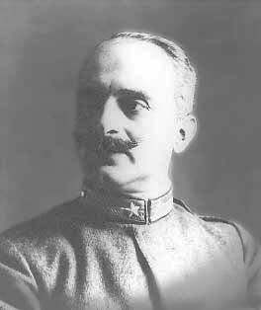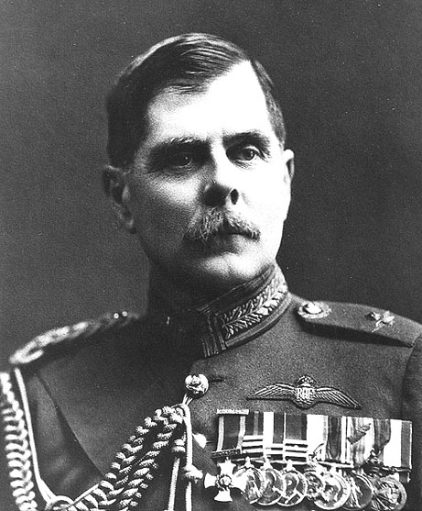
Gen. Giulio Douhet CAM Sir Hugh “Boom” Trenchard, RAF
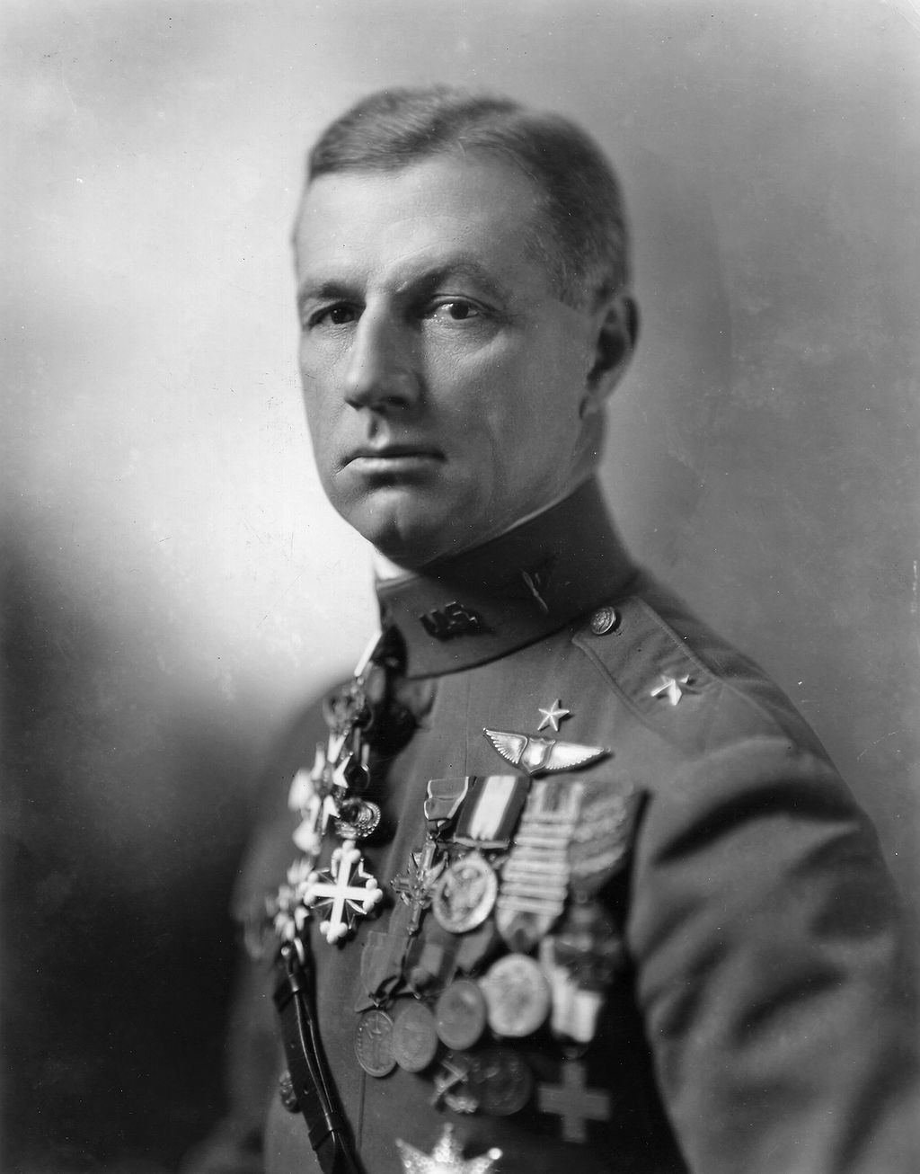
Gen. Walter Wever, Lftwf Brig. Gen. William Mitchell

