Thursday, 12 May 2016
29:12 Volume 29 Number 12
Published by WW II History Round Table
Edited by Dr. Connie Harris
www.mn-ww2roundtable.org

Welcome to the May meeting of the Dr. Harold C. Deutsch World War II History Round Table. Tonight’s speaker is Michael Neiberg, professor of history and the Henry L. Stimson Chair of History and Security Studies in the Department of National Security and Strategy at the US Army War College. He will discuss his latest work, Potsdam, offering a different interpretation of that conference as an effort to correct the mistakes of Versailles rather than as the opening salvo of the Cold War.

Historians often mark the start of the Cold War with either the Yalta Conference of February 1945 or the Potsdam Conference in August, 1945. Despite growing tensions, none of the Great Powers (Great Britain, the United States, and the Soviet Union) were cognizant of that future conflict when they met in Berlin in 1945. Rather, they worried about making the same mistakes as the diplomats of 1919. To them the Second World War did not begin with the Nazi invasion of Poland in 1939 but on a street corner in Sarajevo in 1914.

The Versailles Conference of 1919 loomed large on the minds of the men who gathered at Potsdam. Much like 1919 it would be a gathering of victorious powers. There would be no German or Italian participation. Moreover, France would have no say at the conference, even with Charles De Gaulle's bluster, that once great power would only be given the scraps the Big Three allowed it. Poland and the other Eastern European countries would also have no say since their fates were sealed by the invading Soviet Armies.

Great Britain, even though a victor and still a Great Power with a seat at the table, was a pretender in spite of the haughty talk of Prime Minister Winston Churchill. Britain’s dire economic situation made it a junior partner to the United States. Churchill and Anthony Eden tried to pass themselves off as the elder statesmen and the tutors to the new US President, Harry Truman, but were impotent when it came backing up any of their ideas with real power. Their tutelage came to naught in any case since Churchill was replaced in the midst of the conference with the new Labor Party Prime Minister, Clement Attlee.

Attlee too was new to the world of diplomacy, but he was luckier in the sense that he had been informed of decisions by Churchill’s government. By contrast, Harry Truman came into office two months before the conference, upon the death of Franklin Roosevelt, knowing few details regarding the administrations previous dealings with Great Britain and the Soviet Union. They faced Josef Stalin of the Soviet Union, who worried about the transient nature of leaders of democracy and whether they might not to back out of their commitments, like the United States did with the Versailles Treaty of 1919.

One of the highlights of the Versailles Treaty was Woodrow Wilson’s ideal of national self-determination. This is the idea that an ethnic groups would have the right to form their own nation state. In 1914, nationalism proved to be an important concept for the people living under the Hapsburgs, Hohenzollern, and Romanov Empires. The Versailles Treaty carved out the countries of Poland, Czechoslovakia, Hungary, Rumania, and Yugoslavia to bring Wilson’s ideas to fruition, even if the ethnicities of their citizens did not follow a strict interpretation. This Wilsonian ideal seemed to lay in ruin in 1945, the Eastern European countries were under the domination of the Soviets and ethnic groups were involuntarily re-shuffled throughout Europe. National self-determination was settled at the point of a gun in Europe, but it would survive in the rest of the world after 1945 with the slow demise of the British and French colonial empires.

When Truman departed Potsdam, the conference was considered a success, because it solved the problems of the years 1914 to 1945 as the conferees understood them, most notably the German question. The Cold War still lay in the future, but the “long peace” established at Potsdam proved to be more durable than the ghost of Versailles.

Further Readings:
Michael Neiberg, Potsdam: The End of World War II and the Remaking of Europe (New York: Basic Books, 2015).
Michael Dobbs, Six Months in 1945: FDR, Stalin, Churchill, and Truman – from World War to Cold War (New York: Vintage Books, 2012).
Wilson Miscamble, From Roosevelt to Truman: Potsdam, Hiroshima, and the Cold War (New York: Cambridge University Press, 2007).
Charles Mee, Meeting at Potsdam (New York: M. Evans & Co., 1975).
Herbert Feis, Between War and Peace: The Potsdam Conference (Princeton, NJ: Princeton University Press, 1960).

Announcements:
Twin Cities Civil War Round Table -
May 17, 2016 – Lee’s Dilemma - www.tccwrt.com - info@tccwrt.com
St Croix Valley Civil War Round Table - May 23, 2016 – Benj. White & 1st Wisc. - 715-386-1268 – rossandhaines@comcast.net
Cannon Valley CWRT - May 19 - CW Stories from Ft. Snelling Nat Cemetery
Minnesota Military Museum, Camp Ripley, 15000 Hwy 115, Little Falls, MN 56345, 320-616-6050, http://www.mnmilitarymuseum.org/
Honor Flight - Jerry Kyser - crazyjerry45@hotmail - 651-338-2717
CAF - Commemorative Air Force - www.cafmn.org 651-455-6942
Minnesota Air Guard Museum - www.mnangmuseum.org 612-713-2523
Friends of Ft. Snelling, www.fortsnelling.org
Fagen Fighters WWII Museum, Granite Falls, MN, 320-564-6644, http://www.fagenfighterswwiimuseum.org.
World Without Genocide, 651-695-7621, http://www.worldwithoutgenocide.org/
Airshow - Eden Prairie - July 2016
www.wotn.org 952-746-6100
Fort Snelling Civil War Weekend, Aug. 2016
Military History Book Club, Har Mar Barnes & Noble: 25 May Dobbs, Six Months in 1945 - sdaubenspeck52@gmail.com

We need volunteers to drive our veterans to and from meetings. Please contact Don Patton at cell 612-867-5144 or coldpatton@yahoo.com

Round Table Schedule 2016-2017
2016
8 Sept From Holocaust to US Soldier
22 Sept 1930s Pacific Diplomacy
12 Oct 11th Airborne, PI to Occupation
27 Oct Germany in the 1930s
10 Nov Deutsch Lecture - Sentencing at Nuremburg
8 Dec Countdown to Pearl Harbor (75th Anniv)
2017
12 Jan Battle of Koenigsburg
9 Feb Nazi Hunters
9 Mar Arsenal for War
23 Mar Gen. Lesley McNair
13 Apr Last Mission of the 93rd Bomb Group
11 May Corps Commanders of the Battle of the Bulge
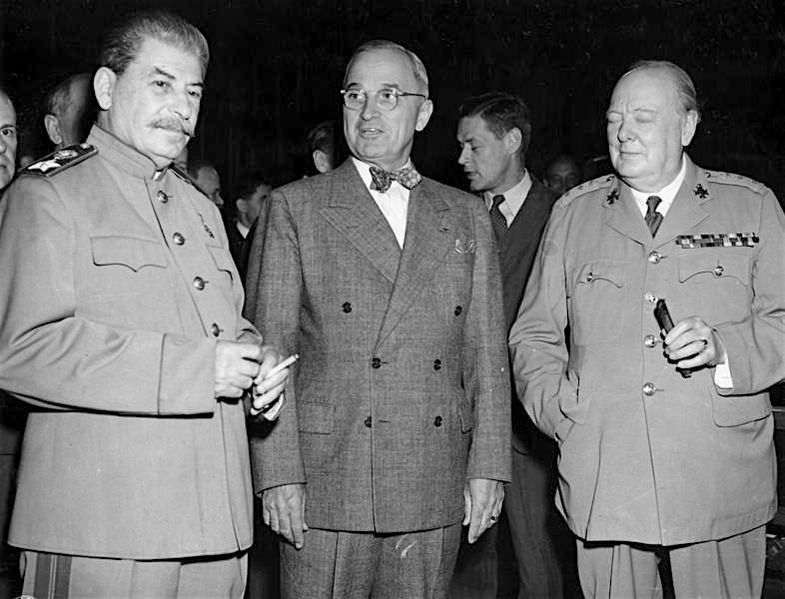
Stalin, Truman, and Churchill, Attlee, at Potsdam

