Thursday, 2 October2014
28:02 Volume 28 Number 2
Published by WW II History Round Table
Edited by Dr. Connie Harris
www.mn-ww2roundtable.org

Welcome to the first October meeting of the Harold C. Deutsch World War II History Round Table. Tonight’s meeting is held in conjunction with the 44th Annual National World War II Glider Pilots Association. Our speaker, Guy Lofaro, author of The Sword of St. Michael, will discuss the dangerous tactics of using gliders to support combat and logistic operations, and will be joined by World War II glider veterans.

Necessity is the mother of invention, and this was never truer than with the development of non-motorized flying vehicles or gliders in the post-Great War era. Prevented from having an air force because of the Treaty of Versailles, Germany turned to gliders to train their future aviators, since there was no mention of gliders in the treaty provisions. Hans von Seekt tried to re-build the German army and former air force pilots, like Herman Goring, tried to a new Luftwaffe by encouraging glider clubs. Glider pilots have to be well trained and know how to maintain altitude without an engine. They use nature’s air thermals and wind variations to keep them aloft. As the popularity of the sport grew in Germany, their pilots were able to stay flying starting from a few minutes to hours at a time. Not bound by any hindrances the development of glider technology in the United States lagged behind the Germans and the Soviets. The US focused its attention on motorized flight, though two celebrity pilots, Charles Lindbergh and his wife Anne, each earned licensure as glider pilots.

Glider flying became a popular sport in the Soviet Union, and the Red Army invested heavily in large transport gliders in support of their paratroop capability. Both the Germans and Soviets led in the development of the “theory of vertical envelopment.” The Soviet/German military rapprochement provided critical illegal/extralegal training to both nations, and in September 1936, Luftwaffe Colonel Kurt Student, a German aviation observer, witnessed a massive 1500 man parachute drop supported by the large transport gliders.
When German rearmament officially began, the glider enthusiasts of the 1920s became the Luftwaffe pilots of the Third Reich. Motorized flight became operationally predominant but the Luftwaffe – paratroopers were airmen – developed gliders for use in paratroop operations. Because of Student’s observations in the Soviet Union the Germans developed a combat glider, DFS 230 (Deutsche Forshungsanhalt Für Segelflug) that had a wing span of 72 feet and was 37.5 feet in length and could carry a pilot and nine fully equipped soldiers. Adolf Hitler personally directed that the gliders be used in landing behind the lines in France and Belgium.
The successful capture of Fort Eban Emael in Belgium, by the Germans proved to be a ‘wake-up’ call to Great Britain and the Japanese who grasped the military potential of gliders. Since there were no engines on a glider they were ‘silent’ and able to land in enemy held areas. Winston Churchill ordered the creation of a parachute force and an experimental glider unit. The British developed the Airspeed Horsa, which could hold up to 28 troopers, and the seven ton capacity General Aircraft Hamilcar cargo glider that could carry vehicles, anti-tank guns, and light tanks into action. The most famous British military action using gliders was the unsuccessful 1942 OPERATION FRESHMAN against a German heavy water plant in Norway. The success at Eban Emael overshadowed the costly failures of glider borne forces during the invasion of Crete in 1941, lessons the Allies would also learn the hard way.
The United States noted the German successes, but just filed the intelligence reports. Finally, in February 1941, General “Hap” Arnold ordered the initiation of a glider development program. This program, though an urgent priority, was not to disrupt the production of motorized airplanes. Therefore, separate civilian manufacturers, not already making motorized aircraft, contracted to build the gliders designed by the Waco Aircraft Company in Troy, Ohio. Approximately 14,000 CG-4A gliders were built, and 3,600 were used in combat. Ford Motor Co. was the United States’ largest producer of the CG-4A (4,109)and Northwestern Aeronautical Corp., located in the old American Radiator factory near Prior and University Avenues in St. Paul, made about 1,509 CG-4As.
The CG-4A had a wingspan of 83.6 feet and an overall length of 48 feet. Since gliders only made one way missions they were constructed from common, and inexpensive materials like steel tubing, canvas, and plywood. After the aircraft’s mission was completed, it was left for the local population to recycle it.
Only about 6,000 men qualified as glider pilots. After their combat landing, they became infantrymen until they were able to rejoin their unit in order to fly their next mission. This duality of their military training and experience sets them apart from other World War II air corps personnel.
American forces first used gliders in the invasion of Sicily (OPERATION HUSKY). They were also used in the Pacific Theater in OPERATION THURSDAY in Burma, and on Luzon. The most famous use of gliders was in OPERATION OVERLORD in June 1944. They were also employed in OPERATION MARKET GARDEN, and in crossing the Rhine. Special glider assault regiments were part of the 11th, 13th, 17th, 82nd and the 101st airborne divisions. The troops landing by gliders were referred to as air landing troops rather than paratroopers, who landed via parachutes. Both air assault forces were used in Normandy.
The history of the military gliders and their pilots is a little known tale in the annals of World War II, but that should never detract from the audacity shown by these men in carrying out their missions. Sometimes the lesser known stories dazzle the imagination the most.

Further Readings:
Gerard Devlin, Silent Wings: The Saga of U.S. Army and Marine Combat Pilots During World War II (New York: St. Martin’s Press, 1985).
John L. Lowden, Silent Wings at War: Combat Glider Pilots in World War II (Washington D.C.: Smithsonian Books, 2002)
James E. Mrazek, Airborne Combat: The Glider War/Fighting Gliders of WWII (Mechanicsburg, PA: Stackpole Books, 2011)
J. Norman Grim, To Fly the Gentle Giants: The Training of U.S. WWII Glider Pilots (Bloomington, IN: Authorhouse, 2009).
Charles J. Masters, Glidermen of Neptune: The American D-Day Glider Attack (Carbondale, IL: Southern Illinois Press, 1995).
Donald J. Rich & Kevin William Brooks, Glider Infantrymen: Behind Enemy Lines in World War II (Williams-Ford Texas A&M University Military History Series) (College Station, TX: Texas A&M University Press, 2011)
Announcements:
Twin Cities Civil War Round Table -
Oct. 21, 2014 – Rebel POWs - www.tccwrt.com - info@tccwrt.com
St Croix Valley Civil War Round Table - Sept. 29, 2014 – Antietam - 715-386-1268 – rossandhaines@comcast.net
Rochester WWII History Round Table –507-280-9970; www.ww2roundtable-rochester.org
Minnesota Military Museum, Camp Ripley, 15000 Hwy 115, Little Falls, MN 56345, 320-616-6050, http://www.mnmilitarymuseum.org/
Honor Flight - Jerry Kyser - crazyjerry45@hotmail - 651-338-2717
CAF - Commemorative Air Force - www.cafmn.org 651-455-6942
Minnesota Air Guard Museum - www.mnangmuseum.org 612-713-2523
Friends of Ft. Snelling, www.fortsnelling.org
Fagen Fighters WWII Museum, Granite Falls, MN, 320-564-6644, http://www.fagenfighterswwiimuseum.org.
World Without Genocide, 651-695-7621, http://www.worldwithoutgenocide.org/
Airshow - Eden Prairie - 11/12 July 2015
www.wotn.org 952-746-6100

We need volunteers to drive our veterans to and from meetings. Please contact Don Patton at cell 612-867-5144 or coldpatton@yahoo.com

Round Table Schedule 2014 - 2015
23 Oct. Thai-Burma Death Railroad
13 Nov. Deutsch Lecture: The OSS
11 Dec. Christmas at Bastogne
8 Jan. Myth of the German Offensive
12 Feb. Italian Struggle
12 Mar. Logistics of War
26 Mar. Return to the Philippines
9 Apr. Air War in the Mediterranean
14 May Retrospective: Goals of WW2 Leaders

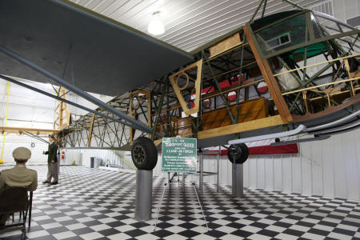
“Our” glider, on display at the Fagen Fighters Museum
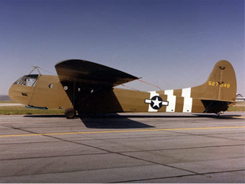
Fully restored CG-4A at Nat. Mus. Of the AF
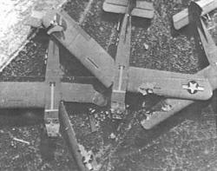
Gliders often landed too close together

