Tuesday, 8 February 2022
35:07 Volume 35 Number 7
Published by WWII History Round Table
Written by Dr. Connie Harris
www.mn-ww2roundtable.org
Welcome to the February session of the Dr. Harold C. Deutsch World War II History Round Table. Tonight’s speaker is Bonnie Gilbert, author of Building for War. She will discuss the Battle of Wake Island and its ultimate capture during the Japanese onslaught of December 1941.
The Japanese Imperial Navy attacked US forces on multiple fronts on 7/8 December 1941, most notably at Pearl Harbor, the Philippines, and Guam, but they also attacked a small crescent-shaped atoll known as Wake Island. Pearl Harbor was a “hit and run” attack lasting a little over an hour. The larger Philippines Island chain held out for six months and was never completely subdued. Guam surrendered after three days. Wake, the smallest in area and numbers of defenders, held out against the Japanese until 23 December. Though a US defeat, the resolute determination of the defenders proved to be a morale boost for a country reeling from massive losses of men, equipment, and national pride.
Formed around the cone of a dormant volcano, Wake Island was a coral atoll, consisting of three islets. Wake, the largest was the middle one, with Peale on the north side and Wilkes on the south side. Since these were essentially a large coral reef, the soil consisted of small sharp pieces of coral, not soft Pacific island sands, and those stationed there wore tennis shoes or boots to keep their feet from being shredded on the bits of coral. While the island did have a large amount of vegetation and sea birds, there were no indigenous mammal species. The explorers, sailors and finally civilians who visited the island brought along rats, a constant problem for the human population.
Although believed to be discovered in the 16th century as part of the Age of Discovery when European seamen sailed around the world, Wake provided no bounty of wealth to make it worthy of settlement. The United States claimed Wake after the Spanish-American War in 1898. Many thought it would provide a coaling station link to the Far East, but it proved less attractive than Midway or Guam. Wake became significant only in the mid-1930s when Pan American Airways designated the island as a stopover spot for its transpacific amphibious air service. With Pan Am in control the island changed considerably, with the building of a small airport, hotel, and docking facilities on Peale islet.
Even in 1940, no aircraft carried enough fuel to cross the Pacific and flew several “legs” between fueling points. Most oil-burning ships and all coal-fueled vessels needed similar fuel depots. Wake, previously too insignificant and poorly located to serve as a coal or oil depot now became commercially important for air travel. The island also gained new importance in the US Navy’s vision for Pacific Ocean operations.
In January 1941, with the Japanese threat growing, the US Navy built a base on the islands. In August, the Navy sent a part of the 1st Marine Defense Battalion and then a Marine Corps fighter squadron with 12 F4F Wildcat fighters. The Navy also had 68 personnel stationed there, and there were over 1200 construction workers. While this may seem like a small group, it is amazing that all these people fit on the small island. The 8 December Japanese attack began with 36 Mitsubishi bombers taking out eight of the fighters, luckily four of the US planes were in the air and were not damaged. The construction workers became Marines that day, manning whatever weapon they could to help. The next day the fighters took down two bombers. Luckily the Marine artillery pieces acquired from the USS Texas and smaller guns were not hit. Many of the Pan Am employees were evacuated when one of their flying boats landed safely and avoided the attack.
The Japanese attempted their first invasion on 10 December. The surviving Wildcat fighters and the artillery repelled the troops and sank two Japanese destroyers. These were the first Japanese ships sunk by American forces. The initial victory by US forces proved pyrrhic, their men and supplies were dwindling, and the problem of resupply proved insurmountable.
Much like the other American-held Pacific islands, such as the Philippines and Guam, Wake Island could not be resupplied in time after the initial Japanese attack. Distance and the availability of materiel and munitions were the primary culprits. As the northernmost atoll in the Pacific Coral Seas, it lies 2304 miles from Honolulu and 1501 miles east of Guam. Wake is also 2000 miles nearer to Japan than to the American mainland. US Naval forces were not going to reach Wake in time. On 23 December, Japanese forces began their second assault of the island with a large naval force backed up by 1500 Japanese Marines. Even though they were successful, the invasion proved costly with over 300 Japanese killed compared to 49 Americans.
Wake Island would be occupied by the Japanese until the end of the war, and much of the military personnel and contractors would be transferred to prison camps in China or Japan. One Marine radio specialist, Lt. Col. Walter Bayler, was flown out on the last plane, a Navy PBY Catalina. He told the tale of what happened during the siege. Much like Custer’s Last Stand, the noble defeat of the US forces on a tiny strategically unimportant atoll in the vast Pacific became a rallying point for a bereft demoralized America. Before the Doolittle Raid, the Battle of Midway, or the Coral Sea, there was Wake.
FURTHER READINGS:
Bonnie Gilbert, Building for War: The Epic Saga of the Civilian Contractors and Marines of Wake Island in World War II (Philadelphia, PA: Casemate, 2012).
Gregory Urwin, Facing Fearful Odds: The Siege of Wake Island (Lincoln, NE: University of Nebraska Press, 1997).
Robert Cressman, A Magnificent Fight: The Battle for Wake Island (Annapolis, MD: Naval Institute Press, 2005).
John Wukovits, Pacific Alamo: The Battle for Wake Island (New York: New American Library, 2003).
Bill Sloan, Given up for Dead: America’s Stand at Wake Island (New York: Bantam Books, 2003).
Announcements:
Twin Cities Civil War Round Table – 15 Feb. 2022 –Re-education of US Grant In Missouri – www.tccwrt.com - info@tccwrt.com
St. Croix Valley Civil War Round Table – 24 Feb. 2022 – Civil War Saddles - 715-386-1268 - rossandhaines@comcast.net
Military History Book Club, Har Mar Barnes & Noble - TBD - sdaubenspeck52@gmail.com
Minnesota Military Museum, Camp Ripley, 15000 Hwy 115, Little Falls, MN 56345 - 320-616-6050 - http://www.mnmilitarymuseum.org/
Minnesota Air Guard Museum - 612-713-2523 - www.mnangmuseum.org
8th AF Historical Society of MN, KC Hall Bloomington, Wednesdays at 1130 - https://www.8thmn.org.
Friends of Ft. Snelling - www.fortsnelling.org
World Without Genocide - 651-695-7621 - http://www.worldwithoutgenocide.org/
Fagen Fighters WWII Museum, Granite Falls, MN - Air show – 18 June 2022 - 320-564-6644 - http://www.fagenfighterswwiimuseum.org.
Wings of the North Airshow - Eden Prairie – 22-24 July 2022 - 952-746-6100 - www.wotn.org
Alliance Française 612-332-0436 - www.afmsp.org
Selim Center for Lifelong Learning, UST, https://www.stthomas.edu/selimcenter/
Western Naval Historical Association
info@wnha.net
Honor Flight - Jerry Kyser - 651-338-2717 - crazyjerry45@hotmail.com
CAF - Commemorative Air Force - 651-455-6942 -www.cafmn.org

We need volunteers to drive our veterans to and from meetings. Please contact Don Patton at cell 612-867-5144 or coldpatton@yahoo.com
Round Table Schedule 2022
8 Mar. Nuremburg Trials – Goering
22 Mar. Aid to Downed Air Crews
12 Apr. Doolittle Raid
10 May Last Battle: in the Alps
The Round Table is a 501.c.3 non-profit.
We would greatly appreciate your
supporting the HCDWW2RT.
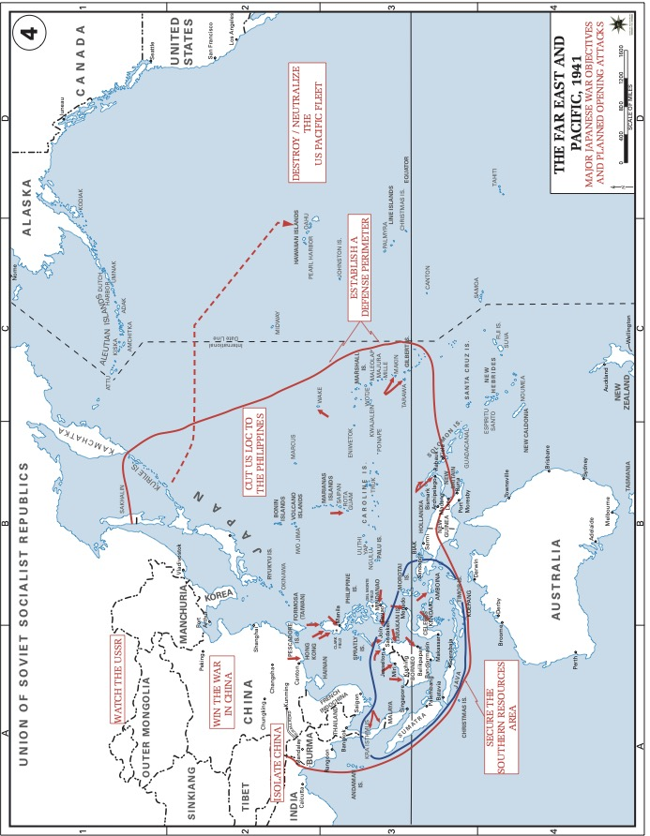
USMA Atlas online Japanese War Plan Objectives
https://www.westpoint.edu/sites/default/files/inline-images/academics/academic_departments/history/WWII%20Asia/WWIIAsia04.pdf
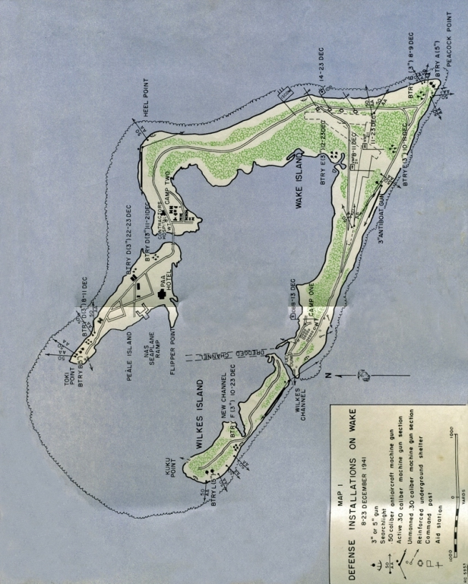
https://weaponsandwarfare.com/2016/06/29/defense-of-wake-island-1941/

