Tuesday, 9 March 2021
34:08 Volume 34 Number 8
Published by WWII History Round Table
Written by Drs. Chris Simer and Connie Harris
www.mn-ww2roundtable.or
Welcome to the first March session of the Dr. Harold C. Deutsch World War II History Round Table. Tonight’s speaker is Mary Lou Gjernes, former Curator of the U.S. Army Art Collection. She will discuss the acquisition and disposition of the several categories of Nazi Art and the assistance of a Minnesota Unit in returning of some them to Germany.
The twentieth century was distinguished by the development and ever more sophisticated use of mass media propaganda in warfare. Motion pictures, radio, and graphic arts were used by all the belligerents in World War II to foster morale, sell war bonds, and to call the population to duty. Graphic art in the form of war posters created images that are still potent today. For instance, the United States’ Rosie the Riveter’s iconic “We Can Do It” still resonates for contemporary feminists. Britain’s laconic Blitz-era message “Keep Calm and Carry On” can be seen across our country. Many of the belligerents also sponsored works of fine Art in oils and watercolors to create lasting impressions of military life, the rigors of combat, and the bravery of the troops.
The Third Reich may have had the most integral and comprehensive consciousness of art and culture of all the belligerents. Adolf Hitler started out as an artist and never failed to emphasize the importance of painting, sculpture, and cultural life as central to his world view. “One cannot understand National Socialism without understanding Wagner,” as Hitler put it. He personally designed the Nazi flag and symbols and orchestrated the massive pageantry of the Nuremberg rallies and torchlight parades. He personally selected Leni Reifenstahl to direct the award winning films The Triumph of the Will (1935) and Olympiad (1938) because he admired her work. Hitler was distinctly proud of his founding of the House of German Art in Munich (1937) and suppressed and banned so-called “Degenerate Art” of an “un-German” nature. A fusion of Art Deco and Neo-Classical realism characterized the visual art the regime so admired (such as Arno Breker’s monumental sculptures) and Albert Speer’s architectural achievements (Berlin’s Olympic stadium).
After the seizure of power and the consolidation of all media under Dr. Paul Joseph Goebbels’ Ministry of Propaganda and Enlightenment and its related organizations, Nazi aesthetics dominated German cultural life. Before the war, motifs predominated featuring idealized Aryans enjoying the benefits and progress of the “New Germany”. Nazi kitsch was everywhere: from toy soldiers and board games to framed quotations from Hitler being displayed in many German homes. Young, strong, and hardworking Germans in factories, in fields, sojourning in nature, or participating in party organizations were also common images in art. A distinctly Nazi emphasis on the nude body (virile warrior-men and fecund and callipygous women) highlighted Nazi obsessions with health, purity, and strength.
When war started skilled artists were attached to many German combat units on land, sea, and air. The United States and Britain also put artists and photographers with their units. War photography and official films and newsreels (Die Deutsche Wochenschau) portrayed the “reality” of the war. Paintings and watercolors allowed for greater emotional depth for the same often propagandistic messages. In the early years of the war, with German troops victorious on every front, artists would capture vignettes of artillery positions, troops relaxing behind the lines, sleek Luftwaffe aircraft or Kriegsmarine vessels driving forward. After 1942, the tone began to shift and by 1944 the stress and strain of battle were often very vividly portrayed. One can detect maudlin and pessimistic qualities to later German war art, alternating between scenes of ruin and desolation at home as well as the battle front, and grimly determined soldiers preparing to defend their positions from attack. Gone were the fresh-faced brilliant colors of 1940: by 1944 gray, browns, and neutrals tended to predominate. To the very end, the importance of “cultural warfare” to the regime was striking: Goebbels took troops out of the line to be extras in the extravagant battle scenes in his answer to Gone with the Wind, the Napoleonic epic Kolberg (1945). It was deemed more important to complete this film, dramatizing a last ditch defense of a Prussian town against the French invader, than it was to put these resources in the direct defense of the Reich. The limited ability to even show Kolberg in the ruined cinemas of German cities blunted its persuasive strength.
With Germany defeated, the US Army made retrieving stolen art treasures and restoring cultural artifacts a major priority, but what to do with enormous collections of Nazi fine art and war art in American possession? Large numbers of Nazi paintings from before and during the war were collected and shipped back to the United States as the spoils of war.
The official policy of de-Nazification, especially after the foundation of the German Federal Republic (1949), banned all Nazi images and flags, art, books, and symbols of any kind from public display. This has created a strange situation both in the United States and Germany over what to do with Nazi era art. On the one hand, overtly Nazi themes and imagery are today considered offensive, and there is an apprehension that neo-Nazi sympathizers would exploit such art. One could say that the latent power of these images, so carefully fostered by the regime, is still strong. On the other hand, this art is a valuable body of historical artifacts, the destruction of which could viewed as attempting to erase the memory of the Third Reich. As a result, this art is not available for the public to see in either Germany or the United States, but it has not been destroyed and huge collections of Nazi era art are gathering dust in various state and military archives. A case can be made that portrayals of purely military subjects are not overtly Nazi enough to offend. But even this is controversial – given the integral ethos, a subtle element in art from the Third Reich. Even a landscape of Norway from this time could be viewed as having a Nazi element to it. At present these works of art are on hold and some archives require visitors to receive special permission to access this art.
The passion and intensity of emotion associated with controversial art can be seen in the contentious efforts today to destroy or conceal statues of American historical figures to somehow “improve” the past. Thus, the power of art, especially art with a dangerous legacy still affects contemporary politics.
Further Readings:
John Paul Weber, The German War Artists (Columbia, SC: The Cerberus Book Company 1979)
Peter Adams, Art of the Third Reich (New York: Harry N. Abrams Inc., Publishers, 1992)
Jonathan Petropoulos, Art as Politics in the Third Reich (Chapel Hill, NC: University of North Carolina Press, 1996)
Stephanie Barron, Degenerate Art: The Fate of the Avant-Garde in Nazi Germany (New York: Harry N. Abrams Inc., Publishers, 1991)
Announcements:
Vietnam War Roundtable – Fall of Saigon – Covid permitting, May 2021
World War I Roundtable (zoom) 10 Mar. 2021 –
Post-9/11 Roundtable (zoom) 29 Mar. 2021 –
– rdietrich@mnmilitarymuseum.org
Twin Cities Civil War Round Table – 16 Mar. 2021 – Gone with the Wind & Construction of Civil War Memory - www.tccwrt.com - info@tccwrt.com
St. Croix Valley Civil War Round Table - TBD - 715-386-1268 - rossandhaines@comcast.net
Military History Book Club, Har Mar Barnes & Noble - TBD - sdaubenspeck52@gmail.com
Civil War Symposium -TBD - info@tccwrt.com
Minnesota Military Museum, Camp Ripley, 15000 Hwy 115, Little Falls, MN 56345 - 320-616-6050 - http://www.mnmilitarymuseum.org/
Minnesota Air Guard Museum - 612-713-2523 - www.mnangmuseum.org
8th AF Historical Society of MN, KC Hall Bloomington, Wednesdays at 1130 - https://www.8thmn.org.
Friends of Ft. Snelling - www.fortsnelling.org
World Without Genocide - 651-695-7621 - http://www.worldwithoutgenocide.org/
Fagen Fighters WWII Museum, Granite Falls, MN - Air show - TBD - 320-564-6644 - http://www.fagenfighterswwiimuseum.org.
Wings of the North Airshow - Eden Prairie – 24-25 July2021 - 952-746-6100 - www.wotn.org
Winston Churchill Book Club - lin.hopkins@hotmail.com
Alliance Francaise 612-332-0436 - www.afmsp.org
Honor Flight - Jerry Kyser - 651-338-2717 - crazyjerry45@hotmail.com
CAF - Commemorative Air Force - 651-455-6942 -www.cafmn.org
Selim Center for Life Long Learning, UST, https://www.stthomas.edu/selimcenter/
Western Naval Historical Association
info@wnha.net
MacArthur Memorial, Norfolk VA, http://www.macarthurmemorial.gov
National World War II Memorial, Washington DC, http://www.wwiimemorialfriends.org

We need volunteers to drive our veterans to and from meetings. Please contact Don Patton at cell 612-867-5144 or coldpatton@yahoo.com
Round Table Schedule 2021
23 Mar Nazi Scientists in US Space Program
13Apr The Tragedy of Poland: Nazis; Soviets
11 May The “Mighty Eighth” and Victory in Europe
The Round Table is a 501.c.3 non-profit.
We would greatly appreciate your
supporting the HCDWW2RT.
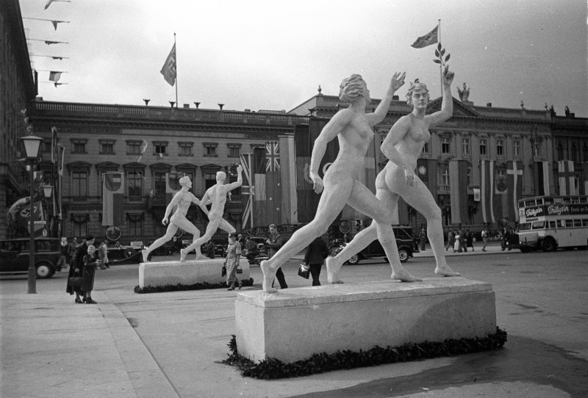
1936 Berlin Olympics – street statuary
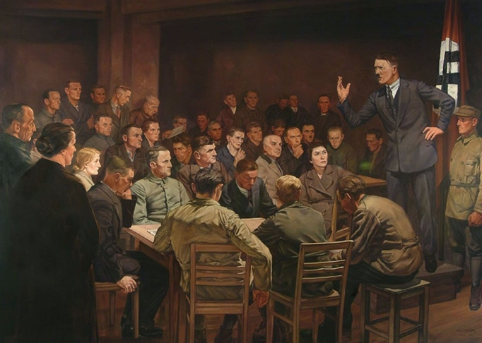
“In the Beginning Was the Word,” Hermann Hoyer (1937)

