Thursday, 14 Dec. 2017
31:05 Volume 31 Number 5
Published by WW II History Round Table
Written by Drs. Connie Harris & Christopher Simer
www.mn-ww2roundtable.org
Welcome to the December meeting of the Dr. Harold C. Deutsch World War II History Round Table. Tonight's speaker is Michael Collins, author of Voices of the Bulge. He is joined by veterans from the battle to discuss what led to the Allied victory.

Grand battlefield analysis is useful, but nothing makes real the actual experience of war more than hearing the first person accounts of those who lived through it. Those who play “Call of Duty” or other war games, will be attracted to the stories of the people who actually lived through World War II. This is what makes "oral history" so attractive; doing such personal interviews was a very important part Dr. Harold Deutsch's own historical methods. During his illustrious career, he interviewed the German leaders during the 1930s and interrogated defeated German generals at Nuremberg trials. In addition, he traveled through the Ardennes days before the December 1944 German ​offensive.

The idea of a German offensive in the West came to Hitler in September of 1944. His goal of seizing Antwerp would deny the Allies a vital logistical link, and might be grounds for a brokered peace. The Germans realized a successful campaign depended upon four things: surprise, poor weather, rapid progress, and the capture of intact Allied fuel supplies to refuel the​ Wehrmacht.

Since the Normandy landings and breakout in the summer and fall of 1944, the Allies had pushed the Wehrmacht out of France and into Belgium. To hinder German operations, Allied bombers destroyed the rail links and roads of the German supply network. This destruction also hindered the Allied advance, particularly the movement of gasoline, and the “Red Ball Express” could only move fuel so far before it consumed all it carried. In October 1944, the Allied offensive ground to a halt because of fuel shortages. The densely forested Ardennes area, between Wallonia in Belgium, Luxembourg, and France, was thought to be a quiet sector suitable for the inexperienced US 106th Infantry Division, and a rest area for battle weary troops like the 28th and 99th IDs.

In early December 1944, Eisenhower met with Bradley and Montgomery to outline plans for an offensive in January 1945. To Montgomery’s dismay (and Patton’s too), Eisenhower wanted to maintain the broad-front strategy, pushing the Germans back all along the entire front, with some focus in the north. Allied planning assumed the Germans lacked the capability to launch a major offensive due to the catastrophic losses the Germans had suffered with the destruction of Army Group Center in the Soviet Operation Bagration that summer.

While the Allies prepared for their offensive, there were indications that the Germans were up to something. Ultra intercepts indicated that there was a buildup of ammunition and fuel dumps across the line in the Ardennes. The Germans had the advantage of closer interior lines that reduced their problems of supply, and the effectiveness of Ultra was very limited since they could use telephone and telegraph networks that could not be intercepted by the Allies. They were defending their homeland and took extreme care to conceal their preparations.
With thick cloud cover and snow obscuring the area and negating Allied air superiority, the Wehrmacht launched a three-pronged offensive on 16 December, along a fifty-mile front in the Ardennes between Monschau and Echternach, taking the Allies by surprise. In the north, Sepp Dietrich’s VI Panzer Army attacked and met stiff resistance from the 99th and 2nd IDs that held the critical Monschau and Elsenborn Ridge which denied the Germans critical roads. In the south, Brandenberger’s VII Army pushed toward Luxembourg trying to secure the flank from Allied armies. In the center, von Manteuffel’s V Panzer Army attacked toward Bastogne and St. Vith, both critical road junctions.
St. Vith held out for six days before British Field Marshall Bernard Montgomery ordered a withdrawal to set up more defensive positions. Eleven hard-surfaced roads converged at Bastogne and it was imperative for the advance that it be taken. Defended by the elements of the 10th Armored Division reinforced by the 101st Airborne, Bastogne refused to surrender, causing serious delays in the German offensive schedule. By 21 December the Germans had Bastogne surrounded; they demand surrender from BG Anthony McAuliffe (101st’s Artillery commander) the acting commander of the 101st Airborne. He refused, uttering the memorable and (to the Germans) confusing reply: “NUTS!” The encircled force was finally relieved by Patton’s 4th Armored Division on 26 December. By mid-January 1945, the Germans were pushed back to where they had started the offensive, with the loss of 100,000 men, severely crippling their military capabilities. For the Americans, the Battle of the Bulge was the bloodiest battle of World War II, with over 100,000 casualties.

By transferring the last effective Panzer units to fight and be defeated in the Bulge, Hitler recklessly left the Eastern Front even less able to respond to the massive Soviet offensive driving towards the Reich. Thus, the entire offensive was a strategic mistake, for even a victory for the Germans would have done nothing to stop the Russian onslaught which would soon be driving on Berlin.

FURTHER READINGS:
Martin Collins & Martin King, The Tigers of Bastogne: Voices of the 10th Armored Division in the Battle of the Bulge. (Casenatem 2013).
Martin Collins & Martin King, Voices of the Bulge (Minneapolis, MN: Zenith Press, 2011).
Charles McDonald, A Time for Trumpets (New York: Harper Collins, 1997).
Gerald Astor, Blood Dimmed Tide (New York: Dutton, 1992).
Harold R. Winton, Corps Commanders of the Bulge (Lawrence, KS: University Press of Kansas, 2007).
Anthony Beevor, Ardennes – 1944 (New York: Viking Press, 2015).
John S. D. Eisenhower, Bitter Woods (Cambridge, MA: Da Capo Press, 1995).
Peter Caddick-Adams, Snow and Steel (New York: Oxford University Press, 2014).

Announcements:
Twin Cities Civil War Round Table -
19 Dec. 2017 – Infamous Dakota War Trials 1862- www.tccwrt.com - info@tccwrt.com
St. Croix Valley Civil War Round Table - 22 Jan. 2018 – Two Families in the Civil War - 715-386-1268 - rossandhaines@comcast.net
Fort Snelling Civil War Symposium - 7 Apr. 2018 - info@tccwrt.com
Minnesota Military Museum, Camp Ripley, 15000 Hwy 115, Little Falls, MN 56345, 320-616-6050, http://www.mnmilitarymuseum.org/
Minnesota Air Guard Museum - www.mnangmuseum.org 612-713-2523
Friends of Ft. Snelling, www.fortsnelling.org
World Without Genocide, 651-695-7621, http://www.worldwithoutgenocide.org/
Fagen Fighters WWII Museum, Granite Falls, MN, 320-564-6644, Air show - 16 June 2018. http://www.fagenfighterswwiimuseum.org.
Airshow - Eden Prairie - 14-15 July 2018
www.wotn.org 952-746-6100
Military History Book Club, Har Mar Barnes & Noble: - Toll, Conquering Tide - 31 Jan. 2018 - sdaubenspeck52@gmail.com
Honor Flight - Jerry Kyser - crazyjerry45@hotmail - 651-338-2717
CAF - Commemorative Air Force - www.cafmn.org 651-455-6942

We need volunteers to drive our veterans to and from meetings. Please contact Don Patton at cell 612-867-5144 or coldpatton@yahoo.com

Round Table Schedule 2018
11 Jan. Eastern Front: Stalingrad
8 Feb. Berlin Airlift
8 Mar. American Airpower in World War II
22 Mar. OSS Woman v. Imperial Japan
12 Apr. Lucian Truscott: Greatest Field CO
10 May Marshall Plan: Saving Victory

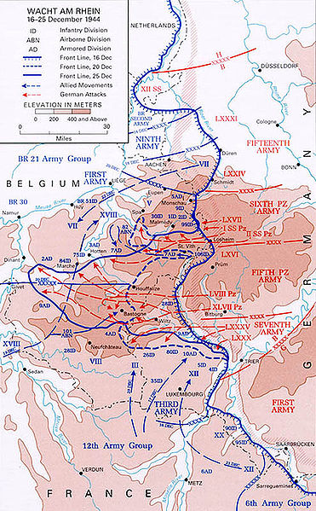
CMH, Battle of the Bulge.
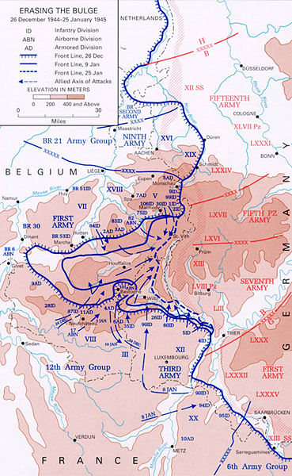
CMH, Battle of the Bulge.

