Thursday, 13 October 2016
30:03 Volume 30 Number 3
Published by WW II History Round Table
Edited by Dr. Connie Harris
www.mn-ww2roundtable.org
Welcome to the first October session of the Dr. Harold C. Deutsch World War II History Round Table. Tonight’s speaker is Jerry Devlin author of Back to Corregidor. He is joined by veterans of the 11th Airborne Division to discuss the vertical assaults in the Philippines and early security in Japan.
The old cliché ‘Necessity is the mother of invention’ was never more true than after four years of senseless slaughter on the Great War’s Western Front. All the great powers desperately searched for ways to break through the stalemate. The Germans had some successes with stormtroop infiltration tactics but did not have the logistical capacity to capitalize on the openings they created. In the fall of 1918 Colonel William P. “Billy” Mitchell, who at the time was General John Pershing’s air service advisor in France, proposed the idea of gathering all the Allied bombers, loading them with men armed with submachine guns who would be dropped by parachutes behind enemy lines to attack rear echelons. The men would be supported by fighter planes until supporting forces arrived. Pershing approved the plan and it was set for the spring of 1919, but the war ended before it could be executed.
During the inter-war years the two international pariahs, the Soviet Union and Germany, seized on and developed the concept of “vertical envelopment,” that is, parachuting infantry troops behind enemy lines to surprise and envelope an opposing force. By 1935, the Soviet Union had battalion sized parachute troops engaging in mass jumps and had even perfected parachuting a tank unto a battlefield. During the 1930s the French, Italians, and Germans all opened military jump schools. The German paratroopers (fallschirmjäger) quickly increased first to regimental and then expanded to divisional strength. In May of 1940 the Germans made the first combat use of paratroopers and glider-borne troops in combat in their attack on the Netherlands, seizing and holding bridges until the infantry forces could catch up. In addition German forces were also able to seize and take the Belgian fortress of Eben Emael. A year later the Germans followed these victories up with the first major airborne operation in history with the invasion of Crete. Maneuver and movement would be the hallmark of the Second World War, and infantry would no longer be continuously sent “over the top” to be slaughtered.
While Billy Mitchell had a good idea at the end of the Great War, the United States lagged far behind the other Great Powers in establishing anything that could conceivably be an airborne unit. What changed was the appointment of General George C. Marshall as the Army Chief of Staff in April 1939. After reading reports from his military attaché in Germany about their development of paratrooper and glider projects, Marshall requested a study on the feasibility of similar American troops. The different sections of the Army fought over who would be in charge of these new units, the engineers wanted them because the soldiers would have to be trained in explosives, the air unit because they would have to jump out of airplanes, and the infantry wanted them to be part of the ground forces. The infantry ultimately won out, but it was not until July 1940 that the First Parachute Test Platoon was formed.
While they started late, the United States proved capable of catching up fast. Once it entered World War II, the United States raised five airborne divisions, the 11th, 13th, 17th, 82nd, and 101st. The 17th, 82nd, and 101st all saw action in the European Theater of Operations. The 11th and 13th were held in reserve in the United States. The 13th was deployed to Europe it did not see combat.
The 11th Airborne, nicknamed “The Angels,” was sent to the Pacific Theater of Operations in early 1944, to New Guinea for intensive jungle training. In November 1944, the Angels landed (in a conventional infantry role) at Leyte Beach in the Philippines. In January, the two glider regiments, operating as infantry, landed on Luzon and fought their way inland, while the paratroop regiment finally conducted a combat drop on Tagaytay Ridge, fortunately unopposed since Filipino forces had secured the target landing zone, but several hundred men were dispersed by jump master errors. After the Liberation of Manila, two companies of paratroopers raided the Los Baños internment camp, liberating some 2,000 civilians. Their final combat in the Islands was near Aparri in support of Filipino and American forces fighting to terminate Japanese resistance on Luzon. They trained for OPERATION OLYMPIC, the invasion of the Japanese home islands, but after the Japanese agreed to surrender, on 30 August 1945 the 11th began occupation duty in Japan and remained there until 1949.
Conceived at the end of the Great War, airborne operations solidified their place in the annals of warfare in the Second World War, and became an integral part of the modern military.

Further Readings:
Gerard Devlin, Paratrooper: The Saga of Parachute and Glider Combat Troops during World War II. (New York: St. Martin’s Press, 1976).
E.M. Flanagan Jr. Airborne: A Combat History of American Airborne Forces (New York: Ballantine Books, 2002).
E.M. Flanagan Jr. The Angels: A History of the 11th Airborne Division, 1943-1946 (New York: Presidio Press, 1989).
William B. Breuer, Geronimo! American Paratroopers in World War II (New York: St Martin’s Press 1991).
James A. Huston, Out of the Blue – U.S. Army Airborne Operations in World War II (West Lafayette, IN: Purdue University Press, 1998).
Announcements:
Twin Cities Civil War Round Table -
18 Oct. 2016 – Battle of Falling Waters - www.tccwrt.com - info@tccwrt.com
St Croix Valley Civil War Round Table - 24 Oct. 2016 – Hollywood’s Civil War - 715-386-1268 - rossandhaines@comcast.net
Cannon Valley CWRT - 20 Oct. Trials after US-Dakota War – dnl1.peterson@gmail.com
Fort Snelling Civil War Symposium - 8 April 2017
Minnesota Military Museum, Camp Ripley, 15000 Hwy 115, Little Falls, MN 56345, 320-616-6050, http://www.mnmilitarymuseum.org/
World Without Genocide, 651-695-7621, http://www.worldwithoutgenocide.org/
Honor Flight - Jerry Kyser - crazyjerry45@hotmail - 651-338-2717
CAF - Commemorative Air Force - www.cafmn.org 651-455-6942
Minnesota Air Guard Museum - www.mnangmuseum.org 612-713-2523
Friends of Ft. Snelling, www.fortsnelling.org
Fagen Fighters WWII Museum, Granite Falls, MN, 320-564-6644, http://www.fagenfighterswwiimuseum.org.
Airshow - Eden Prairie - July 2017
www.wotn.org 952-746-6100
Military History Book Club, Har Mar Barnes & Noble: 26 Oct., Barker, Agincourt: Henry V & the Battle … - sdaubenspeck52@gmail.com

We need volunteers to drive our veterans to and from meetings. Please contact Don Patton at cell 612-867-5144 or coldpatton@yahoo.com

Round Table Schedule 2016-2017
2016
27 Oct Germany in the 1930s
Roundtable Schedule for 2016-2017
10 Nov Deutsch Lecture - Sentencing at Nuremburg
8 Dec Countdown to Pearl Harbor (75th Anniv)
2017
12 Jan Battle of Koenigsburg
9 Feb Nazi Hunters
9 Mar Arsenal for War
23 Mar Gen. Lesley McNair
13 Apr Last Mission of the 93rd Bomb Group
11 May Corps Commanders of the Battle of the Bulge
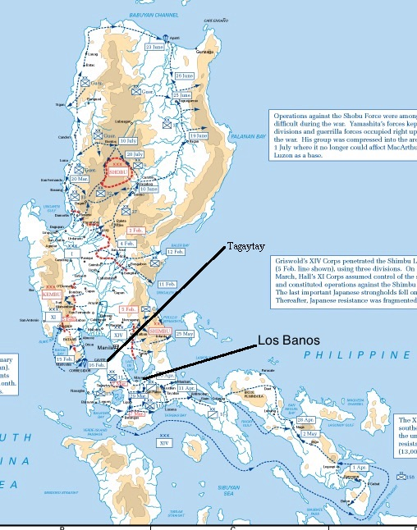
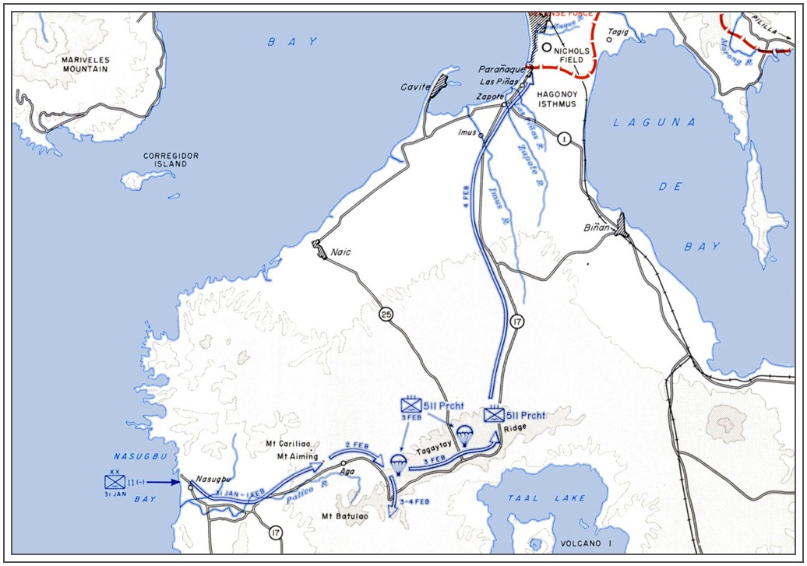
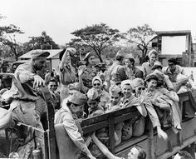
Army Nurses interned at Los Banos, the “Angels [or, “Battling Belles”] of Bataan”

