Thursday, 22 September 2016
30:02 Volume 30 Number 2
Published by WW II History Round Table
Edited by Dr. Connie Harris
www.mn-ww2roundtable.org
Welcome to the September meeting of the Dr. Harold C. Deutsch World War II History Round Table. Tonight’s speaker is Professor Sidney Pash, author of The Currents of War. He will speak on the connecting events from the turn of the 20th century in the Pacific that led to the surprise attack at Pearl Harbor.
One of the most sacred lynchpins of the American diplomatic tradition is the idea of the “Open Door.” This is the notion that the United States should be able to trade unhindered with any county in the world. The policy was first enunciated in 1899 by then Secretary of State John Hay in several notes sent to the European powers. At its beginnings, the “Open Door” specifically focused on American relations with China. In the late 19th and early twentieth century the European powers (British, French, and German) carved out their own “spheres of influence” in a weakened China, and would not allow other countries to trade in their area. The United States believed it had the right to trade anywhere in China on an equal basis as the Europeans. The “Open Door” was seen as a way to expand trade with the populous Chinese market and undermine the imperial intentions of the European powers.
At the same time as the United States was pushing for the Open Door, another imperial power had its sights set on China: Japan. The United States and Japan had maintained cordial relations since Commodore Matthew Perry opened trade relations in 1854. When Japan decided to end its isolation from the world after Perry’s visit, it did not model itself after the United States, but but drew primarily from Germany and Great Britain. Much like Britain, Japan had a large surplus population and few natural resources of its own. Japan wanted control of the Asian-Pacific region to gain land for its people and natural resource to gain status as a great power, and not be subservient to the Western nations.
Japan’s entrance onto the world stage and its bid to be seen as a great power began with the 1905 Russo-Japanese War. The Japanese won a decisive victory over Czar Nicholas’ Empire and the peace negotiated by President Theodore Roosevelt altered the balance of power in North Asia. Japan annexed the peninsula of Korea, acquired the southern half of the Russian Sakhalin Island, and took over the Russia’s Port Arthur enclave in China. Since the Russians did not pay indemnities to Japan, the government was left in dire financial straits and the Japanese people rioted over what they perceived as a second rate peace. (Roosevelt gained the Nobel Peace Prize and international acclaim with the Treaty of Portsmouth.)
Following their victory, the Japanese engaged in a series of agreements with the United States that limited Japanese economic domination in China, consistent with the Open Door,and the US recognized Japanese territorial aggrandizement, first in Korea, and then in Manchuria. The conflicted nature of Japan’s relations with the Western powers continued in the aftermath of the Great War, in which Japan joined the Allies and took over Germany’s concessions in Shandong Province in China and gained control (a mandate) on the German-held Pacific Islands.
During the 1920’s Japan, like the United States, experienced tenuous economic prosperity followed by economic depression in the 1930’s. Japan reacted by expanding its influence in China. In 1931, the Japanese Army launched attacks against Chinese forces in Manchuria, and quickly defeated them, annexing the area and renaming it “Manchukuo”. The US Secretary of State Henry Stimson’s refusal to recognize the annexation in China, known as the “Stimson Doctrine”, soured US-Japanese relations. Even as relations deteriorated, the United States continued to sell scrap metal and oil to the Japanese, whose military forces went to war with China running on American oil. In 1935 and 1936, the US Congress passed the Neutrality Acts which were seen as a way to keep the US from being dragged into another war and prohibited the sale of munitions to countries engaged in war, but neutrality was invoked only when the president recognized a state of belligerency between the nations involved. President Franklin Roosevelt (FDR) did not do so in the conflict between Japan and China, and could therefore continue to supply China with munitions and Japan with oil. In 1937, Japan invaded the rest of China taking large portions of the coastal areas, Peking, and Shanghai. Only in 1939 did the United States begin to challenge Japan’s invasion of China, and finally in 1940, FDR imposed a partial embargo of oil, gasoline, and metals to Japan. It was not until July 1941 that FDR called for a complete embargo of all goods to Japan and froze Japanese assets in the United States. The Japanese responded by moving into French Indo-China. The US offered to lift its embargo if the Japanese complied with the American demands to retreat from China and French Indo-China.
To the Japanese, the choice was clear: submit to the United States demands or go to war. In November 1941, they was decided to do the latter, invading the Philippines, the Dutch East Indies (gaining control of key resources and oil), the British Possessions in the southwest Pacific, and attacking Hawaii. The Open Door closed.
Further Readings:
Sidney Pash, The Currents of War: A New History of American-Japanese Relations, 1899-1941 (Lexington, KY: The University Press of Kentucky, 2014).
Michael Barnhart, Japan Prepares for Total War: The Search for Economic Security, 1919-1941 (Ithaca NY: Cornell University Press, 1988).
Edward S. Miller, Bankrupting the Enemy: The US Financial Siege of Japan Before Pearl Harbor (​Annapolis, MD: Naval Institute Press, 2007).
Edward S. Miller, War Plan Orange: The U.S. Strategy to Defeat Japan, 1897-1945 (Annapolis, MD: Naval Institute Press, 1991).
H.P.Willmott, Empires in Balance: Japanese and Allied Pacific Strategies to April 1942(Annapolis, MD: Naval Institute Press, 2008).
Announcements:
Twin Cities Civil War Round Table -
18 Oct. 2016 – Battle of Falling Waters - www.tccwrt.com - info@tccwrt.com
St Croix Valley Civil War Round Table - 26 Sept. 2016 – Stonewall Jackson - 715-386-1268 - rossandhaines@comcast.net
Cannon Valley CWRT - 20 Oct. 2016 - Dakota War Trials - dnl1.peterson@gmail.com
Fort Snelling Civil War Symposium - 8 April 2017
Minnesota Military Museum, Camp Ripley, 15000 Hwy 115, Little Falls, MN 56345, 320-616-6050, http://www.mnmilitarymuseum.org/
Honor Flight - Jerry Kyser - crazyjerry45@hotmail - 651-338-2717
CAF - Commemorative Air Force - www.cafmn.org 651-455-6942
Minnesota Air Guard Museum - www.mnangmuseum.org 612-713-2523
Friends of Ft. Snelling, www.fortsnelling.org
Fagen Fighters WWII Museum, Granite Falls, MN, 320-564-6644, http://www.fagenfighterswwiimuseum.org.
World Without Genocide, 651-695-7621, http://www.worldwithoutgenocide.org/
Airshow - Eden Prairie - 15-16 July 2017
www.wotn.org 952-746-6100
Military History Book Club, Har Mar Barnes & Noble: 28 Sept., Corum, The Luftwaffe - sdaubenspeck52@gmail.com

We need volunteers to drive our veterans to and from meetings. Please contact Don Patton at cell 612-867-5144 or coldpatton@yahoo.com

Round Table Schedule 2016-2017
2016
13 Oct 11th Airborne, PI to Occupation
27 Oct Germany in the 1930s
10 Nov Deutsch Lecture - Sentencing at Nuremburg
8 Dec Countdown to Pearl Harbor (75th Anniv)
2017
12 Jan Battle of Koenigsburg
9 Feb Nazi Hunters
9 Mar Arsenal for War
23 Mar Gen. Lesley McNair
13 Apr Last Mission of the 93rd Bomb Group
11 May Corps Commanders of the Battle of the Bulge
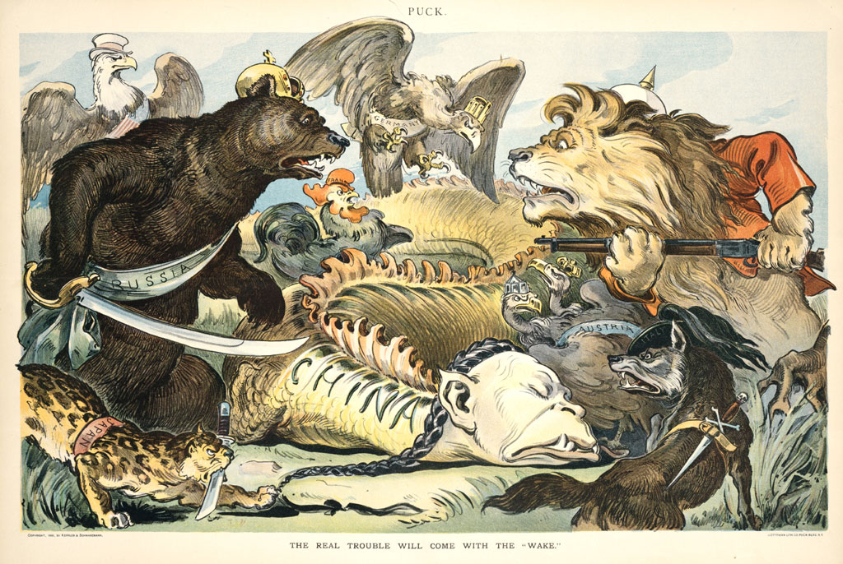
Japan is the Leopard in the bottom left with the knife
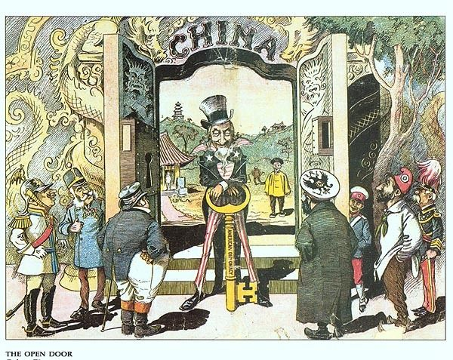
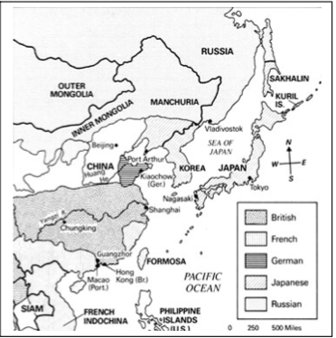
Spheres of influence in China (Russia’s to Japan 1905)

