Thursday, 14 April 2016
29:10 Volume 29 Number 10
Published by WW II History Round Table
Edited by Dr. Connie Harris
www.mn-ww2roundtable.org

Welcome to the first April meeting of the Dr. Harold C. Deutsch World War II History Round Table. Tonight’s speaker is Lieutenant Colonel Scott Wheeler, author of Jacob L. Devers. He will be joined by veterans of the Seventh Army, who will discuss the overlooked Rhone Valley Campaign.

Tonight’s discussion focuses on the Allied campaign in southern France which was largely overshadowed by the campaigns in Italy and Normandy. Controversy also swirls around its significance in the overall Allied strategy and whether it was truly needed or just diminished the strength of other efforts in Italy and northern France.

Planning for the invasion of France began in 1942, and at first it was believed that there would be two components, Operation ANVIL in southern France would be done simultaneously with the Normandy landing, Operation SLEDGEHAMMER. The original idea for this two pronged attack came from General George Marshall at the 1942 Tehran Conference and was supported by Stalin because it kept the British and the United States out of the Balkans. Britain’s Prime Minister Winston Churchill objected to the invasion of southern France believing it would divert forces away from the Italian campaign, and he also wanted an allied invasion of the Balkans to deny Germany oil supplies, slow down the advance of the Soviet’s Red Army and to gain a better negotiating position in post-war Europe. French leaders insisted that ANVIL take place and that French troops play a major role in the invasion.

When Eisenhower left the Mediterranean Theater to take charge of the overall Allied Expeditionary forces at Normandy, Lieutenant General Jacob Devers became the Deputy Theater Commander under its new chief British General Sir Henry Maitland. While in the Mediterranean, Devers pushed for preparations for ANVIL, the invasion of southern France. Because of the Normandy invasion (SLEDGEHAMMER/OVERLORD) and the demands of the Pacific for amphibious vessels ANVIL was canceled in April 1944. Devers would not allow ANVIL to die and refused to re-allocate supplies and equipment already gathered for the invasion. Eisenhower also would not allow ANVIL to die, believing it was best to be fighting the Germans on as many fronts as possible. It was officially resurrected on June 24, 1944 as DRAGOON after the forces in Normandy became bogged down. The invasion took place on August 14th, 1944.
Although not as large as the Normandy forces, General Devers had much to work with in the invasion: General Alexander Patch’s 7th Army consisting of the US VI Corps (US 3rd, 36th, and 45th Infantry Divisions and French 1st Armored) under the command of General Lucian Truscott along with The First French Army, composed of 7 divisions from the Army of Africa under Gen. Jean de Lattre de Tassigny.. These were all well-seasoned veterans of North Africa, Sicily and the Italian campaigns..

After the initial landings in the south, Truscott and the other commanders moved quickly out of the beachhead wanting to prevent another Anzio disaster. Opposing the Allied forces was the Wehrmacht’s Army Group G, commanded by Lieutenant General Johannes Blaskowitz, a cobbled together force of older veterans and undermanned units, with the only one Army, the 19th under the command of Frederick Weise. The Germans were thinly spread along the coast. American and French forces were able to quickly take the ports of Toulon and Marseilles, then VI Corps moved north, linking up with other DRAGOON units. Throughout their north advance, logistics and supplies, particularly fuel, would be a constant problem.

The rapid retreat of the Wehrmacht’s Nineteenth Army resulted in swift gains for the DRAGOON forces and they dashed northward to take Lyon. Within a month of the initial landings Patch’s 7th Army advanced almost 400 miles up the Rhone River Valley to link up with the Third Army to create a solid wall of Allied forces from Antwerp to the Swiss border.

At that juncture, the forces were reorganized into the 6th Army Group under the command of Devers. Eisenhower also decided to make the ​Allies’ main efforts in the North with British General’s Bernard Montgomery’s forces, while Devers, at the extreme south would have to make do.

October 1944 proved to be a difficult month for Devers 6th Army Group with a slow advance through the Vosges Mountains and continuing supply shortages. However, in November, they made the most significant gain along the Allied lines in Western Europe by taking Strasbourg on November 23rd. Even with the continued success of the 6th Army Group, in December, Eisenhower, once again, decided to have his main efforts in the North with secondary attacks in the South.
Considered a success by the Allies, DRAGOON allowed for the liberation of most of France in six weeks, and provided for the largest French military action since 1940. Even so, it is not without its critics, especially from those who believed it took away from their own operations, like Bernard Montgomery to the north and Mark Clark in Italy. One has to wonder though, if Dever’s had been given more fuel and supplies how much further he could have gone. Maybe southern France really was Europe’s “soft-underbelly” of Churchill’s dreams.

Further Readings:
James Scott Wheeler, Jacob L. Devers: A General’s Life (Lexington, KY: University Press of Kentucky, 2015).
William Breuer, Operation Dragoon: The Allied Invasion of the South of France (New York: Presidio Press, 1996).
Steven J. Zaloga, Operation Dragoon 1944: France’s Other D-Day (Oxford, U.K.: Osprey Publishing, 2009).
Jean-Loup Gassend, Autopsy of a Battle: The Allied Liberation of the French Riviera (Atglen, PA: Schiffer Publishing, 2004).
Anthony Tucker-Jones, Operation Dragoon: The Liberation of Southern France, 1944 (South Yorkshire, U.K.: Pen & Sword, 2010).
Jeffrey J. Clarke and Rovert R. Smith, United States Army in World War II, European Theater of Operations; Riviera to the Rhine (Washington, DC: USGPO, 1993).

Announcements:
Twin Cities Civil War Round Table - May 17, 2016 – Lee’s Dilemma - www.tccwrt.com - info@tccwrt.com
St Croix Valley Civil War Round Table - Apr. 25, 2016 – Charleston & Civil War - 715-386-1268 – rossandhaines@comcast.net
Minnesota Military Museum, Camp Ripley, 15000 Hwy 115, Little Falls, MN 56345, 320-616-6050, http://www.mnmilitarymuseum.org/
Honor Flight - Jerry Kyser - crazyjerry45@hotmail - 651-338-2717
CAF - Commemorative Air Force - www.cafmn.org 651-455-6942
Minnesota Air Guard Museum - www.mnangmuseum.org 612-713-2523
Friends of Ft. Snelling, www.fortsnelling.org
Fagen Fighters WWII Museum, Granite Falls, MN, 320-564-6644, http://www.fagenfighterswwiimuseum.org.
World Without Genocide, 651-695-7621, http://www.worldwithoutgenocide.org/
Airshow - Eden Prairie - 16-17 July 2016
www.wotn.org 952-746-6100
Fort Snelling World War I Weekend, 20-21 Aug. 2016
Military History Book Club, Har Mar Barnes & Noble: 27 Apr. Boneman, Amer. Spring … Road to Revolution - sdaubenspeck52@gmail.com

We need volunteers to drive our veterans to and from meetings. Please contact Don Patton at cell 612-867-5144 or coldpatton@yahoo.com

Round Table Schedule 2016
28 Apr. OSS Maritime Units — First SEALS
12 May Start of Cold War

LTGs Truscott, Patch, and Devers, Oct. 1944 (USArmy)
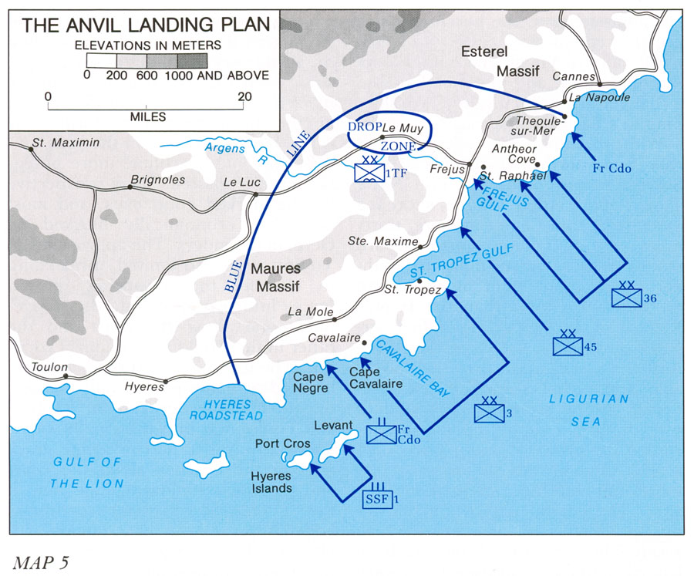
General Situation, Dec. 1944 (USMA map WWII Europe71)

