Thursday, 22 October 2015
29:03 Volume 29 Number 3
Published by WW II History Round Table
Edited by Dr. Connie Harris
www.mn-ww2roundtable.org

Welcome to the second October meeting of the Dr. Harold C. Deutsch World War II History Round Table. Tonight’s speaker is our old friend, Patrick O’Donnell, author of: Operatives, Spies, and Saboteurs; Dog Company; and his new book, First Seals. He will speak on the origins of the elite Special Forces unit that evolved from the Maritime Unit (MU) of the Office of Strategic Services.

Most Americans are dazzled by the ​daring, secretive operations of the Navy SEAL units, witness the popularity of Lone Survivor or American Sniper. Their intense training and missions, like the capture of Osama bin Laden, are legendary. The first evolution of these units began in William Donovan’s secret Office of Strategic Services (OSS) in World War II.

Prior to the War, the United States lacked the capability to really assess the actions of other countries. When war came, we desperately needed information on our enemies – and on our friends. We also needed capabilities like those the British had in SIS, SOE, and other spy and sabotage units. Desperation often breeds innovation, like the OSS. At President Franklin D. Roosevelt’s (FDR) request, William Donovan stepped into this vacuum.

In early 1940, FDR sent Donovan to England to meet with Prime Minister Winston Churchill to find out if England could survive the war. Donovan was given access to British intelligence and to their agents, who encouraged him to set up his own agency. FDR, intrigued by the idea of an independent intelligence agency, signed the executive order creating the Coordinator of Information (COI) in July of 1941. When it began, the Office of Information had one employee, Donovan.

In June 1942, the COI became known as the Office of Strategic Services (OSS) again by Executive Order, and was placed under the control of the Joint Chiefs of Staff. Being under the auspices of the military fit well into Donovan’s background as a World War I veteran. Donovan wanted to command an army, but when that was denied him, he created one, the OSS.

Within two years the OSS would have over 10,000 people. Of particular relevance to tonight’s topic are the people who worked in the Operational Groups (OG) division. Specializing in sabotage, and guerrilla warfare, the OG division included highly trained foreign-language speaking commando teams; and Maritime Units (MU) - that transported agents and supplies to resistance groups and conducted naval sabotage and reconnaissance.

The Maritime Unit (MU) became a separate OSS branch in the summer of 1943, and its primary mission was the “infiltration of agents and operatives by sea, the waterborne supply of resistance groups, execution of maritime sabotage, and the development of special equipment and devices.” The men who became part of these “operational swimmer groups” were hand-picked volunteers from all the armed services and also some “beach rats” - lifeguards and divers from Southern California, even a Hollywood dentist. The training included underwater sabotage, hydrographic charting for amphibious beach assaults, reconnaissance, and special operations. The MU developed special equipment to aid in their missions, such as the Lambertson Amphibious Respiratory Unit (LARU) which enabled a swimmer to approach a target without leaving breathing bubbles, along with specialized devices like underwater compasses, watches, and depth gauges.

Many of the MU missions were done in Europe, particularly to re-supply of resistance groups, and this was dangerous work. One OSS agent, the Hollywood dentist, Jack Taylor was on a re-supply mission and captured by the Germans and ended up in Mauthausen concentration camp until he was liberated in May of 1945. Any underwater sabotage of ships was deemed not necessary because of the pervasiveness of American bombing. In the Pacific OSS-MU operations were minimal. Despite Donovan’s charm, neither Admiral Chester Nimitz nor General Douglas MacArthur welcomed OSS operatives in their areas. The Navy reversed its decision after it realized it needed special operations units when hundreds died on Tarawa because of insufficient reconnaissance of the island’s beaches. The MU operational group, Swimmer Group II, joined forces with the Navy’s Underwater Demolition Team 10 (UDT-10) to conduct underwater reconnaissance on the islands of Peleliu, Angaur, and Yap. After this was done, the teams blew up the coral reefs surrounding the landing beaches to make it easier for operations.

FDR’s death and the end of the war put the OSS on the path to destruction. On September 25, 1945, President Truman signed the order that shut down the OSS, and the different sections of the organization were parceled out to the State Department (R&A) and the Pentagon (secret and counter-intelligence, renamed the Special Services Unit). MU was shut down, but not for long. The Navy kept its UDT units and perfected them with the operational records and training first done by MU, especially with use of the LARU equipment. During the Korean War there were several special operations which led to the creation of a combat swimmer programs in the Army (the Green Berets) and the Navy (SEALS). Completing its evolution from the OSS, in January 1962 SEAL Teams One and Two became operational. Thus, through their descent from the OSS, Donovan was the father of our special operations and information warfare forces, as well as of America’s modern intelligence agency (the CIA).

Further Readings:
Patrick O’Donnell, First Seals (Boston, MA: Da Capo Press, 2014).
Patrick O’Donnell, Operatives, Spies, and Saboteurs (New York: Free Press, 2004).
Francis Fane, The Naked Warriors (Annapolis, MD: Naval Institute Press, 1995)
Douglas Waller, Wild Bill Donovan (New York: Free Press, 2011)
Richard Harris Smith, OSS: The Secret History of the First CIA (Guilford, CT: The Lyons Press, 1972).
United States War Department – Strategic Services Unit History Project, War Report on the OSS (Office of Strategic Services) (New York: Walker and Company, 1976).

Announcements:
Twin Cities Civil War Round Table -
Nov. 17, 2015 – Fort Negley - www.tccwrt.com - info@tccwrt.com - NEW PLACE
St Croix Valley Civil War Round Table - Oct. 26, 2015 – Lowe & Aeronauts - 715-386-1268 – rossandhaines@comcast.net
Rochester WWII History Round Table –507-280-9970; www.ww2roundtable-rochester.org
Minnesota Military Museum, Camp Ripley, 15000 Hwy 115, Little Falls, MN 56345, 320-616-6050, http://www.mnmilitarymuseum.org/
Honor Flight - Jerry Kyser - crazyjerry45@hotmail - 651-338-2717
CAF - Commemorative Air Force - www.cafmn.org 651-455-6942
Minnesota Air Guard Museum - www.mnangmuseum.org 612-713-2523
Friends of Ft. Snelling, www.fortsnelling.org
Fagen Fighters WWII Museum, Granite Falls, MN, 320-564-6644, http://www.fagenfighterswwiimuseum.org.
World Without Genocide, 651-695-7621, http://www.worldwithoutgenocide.org/
Airshow - Eden Prairie - July 2016
www.wotn.org 952-746-6100
Fort Snelling Civil War Weekend, Aug. 2016
Military History Book Club, Har Mar Barnes & Noble: 28 Oct. Wawro, Mad Catastrophe - sdaubenspeck52@gmail.com

We need volunteers to drive our veterans to and from meetings. Please contact Don Patton at cell 612-867-5144 or coldpatton@yahoo.com

Round Table Schedule 2015-2016
2015
12 Nov. War Crimes Trials
10 Dec. Carrier Operations in Pacific
2016
14 Jan. German-Russians Operations
11 Feb. Liberation of Concentration Camps
10 Mar. Mobilization for War
24 Mar. Birth of New Age of War
14 Apr. Operation Dragoon/Anvil
12 May Start of Cold War

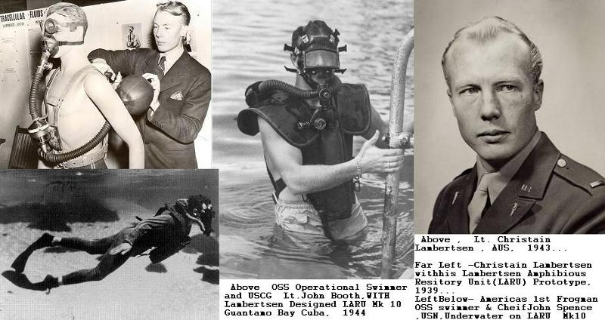
Capt. Christian Lambertsen, MD, combat diver, invented LARU. Received Legion of Merit.

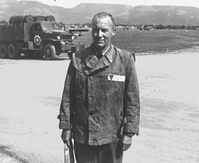 |  | 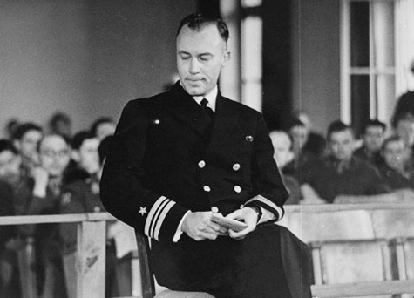
LCD. Jack Taylor, DDS, pictured being liberated from Mauthausen KZL in May, 1945, and testifying before the Military Tribunal at the Dachau KZL in November 1945. Received the Navy Cross.

