Thursday, 12 September 2013
27:1 Volume 27 Number 1
Published by WW II History Round Table
Edited by Dr. Connie Harris
www.mn-ww2roundtable.org

Welcome to the first meeting of the Dr. Harold C. Deutsch World War II History Round Table. We begin our 27th year! Tonight’s speakers are RAF veteran and author of Unflinching Zeal, Dr. Robin Higham and Dr. Roy Heidicker, historian of the Eagle Squadrons, and others who will talk about the aerial defense of England against the Luftwaffe in 1940.

On 18 June 1940, 14 days after the last of the bedraggled remnants of the British Expeditionary Force returned to Britain, Prime Minister Winston Churchill spoke to Parliament and the nation: “What General Weygand called the Battle of France is over. I expect the Battle of Britain is about to begin. … Upon this battle depends the survival of Christian civilization.” The first battle fought wholly in the air, this fight between the Royal Air Force and the German Luftwaffe epitomized the technological Twentieth Century, and was, if not “their finest hour,” was certainly one of those
finest moments.

The interwar period sometimes is viewed as the intermission between halves of a single war. Many of the issues provoking war in 1914 were exacerbated by the “Peace of Versailles” and most remained problems in 1939. Militarily, the second war builds from the first. For example, before World War I ended, air forces conducted strategic bombing, reconnaissance, close air support of troops, and air defense. Only the full capacity of air power remained ambiguous in 1918, though the theorists and aerial strategists were already thinking of future wars in which aviation would be the dominant military force. Nearly everyone wanted to avoid the devastating meat grinder of trench warfare.

The theorists agreed that if air power were to be dominant in future wars, its role would be strategic – bombing key targets critical to the enemy effort, not tactical missions supporting the army or navy. Two prevailing views emerged opposite sides of the Atlantic regarding the choice of targets for strategic bombing. The European air power advocates, like Italy’s Guilio Douhet and the RAF’s Sir Hugh Trenchard believed that civilians were the targets most vulnerable to an enemy attack. The destruction of civilian lives and property through bombing would destroy morale and will to fight, and the population would rebel and force a peace. The American view, advocated by Brigadier General Billy Mitchell, believed that, by attacking the enemy’s “industrial web” – oil refineries, ball-bearing factories, airplane plants, rail yards, etc. – would cripple the enemy’s economy and cause them to sue for peace. Each argument had (and has) its problems, the Europeans failed to recognize the nationalist pride prevalent in their populations, and the Americans overestimated the economic fragility of the modern industrialized state.

When the Battle of Britain began, these views would be put into practice and tested. The British prepared their island nation for what they believed would be a German amphibious invasion. The Germans dithered; not until the end of July did Hitler’s High Command come up with two approaches to defeat the British. The first was a joint-service invasion, – Unternehmen Seelöwe (Operation Sea Lion); the second, an air offensive to gain air superiority and wreck the Britain’s industries. However, Hitler only gave this plan a passing glance, being more interested in invading the Soviet Union. The German Navy could not support an invasion in the aftermath of its losses in the Norwegian expedition and they argued with the German Army. Into the mess, stepped Air Marshal Hermann Göring, who believed that the Luftwaffe by itself could win the battle against Britain.

Göring followed more of the American approach. From their experience in the Spanish Civil War, the Luftwaffe leadership realized that it was difficult to accurately place the bombs on the targets, and that bombing civilians did not reduce or destroy morale. German air options were limited because the Luftwaffe was designed primarily as a close air support air force, with no strategic bombing capability. Despite this, on June 30, 1940, Göring instructed the Luftwaffe to launch strikes targeting the British Fighter and Bomber command bases, ground-support facilities, and the aircraft industries. In addition, their goal was to have a ceaseless attack upon the RAF.

Unfortunately for the Germans, the RAF’s Air Marshal Sir Hugh Dowding had the foresight to prepare England for the onslaught. As head of Fighter Command during the 1930’s, Dowding encouraged the development of radar, observers, plotting, and radio control of fighters into an integrated aerial defense scheme. He also managed to bring into production the Spitfires and Hurricanes that would be critical to the defense of the Island. Having won these grueling battles against Bomber Command and the political establishment, he was asked to defer retirement in June of 1939 in view of the international tensions. After the Battle of Britain was won, he was forced into retirement.

The Luftwaffe first planned to attack Fighter Command bases in the south of England, then they would shift to strike aviation targets all over Britain, rendering the nation defenseless. For this plan to succeed, they needed to achieve aerial superiority if not supremacy, which meant achieving a high kill ratio. Operating with poor intelligence of British plans and capabilities, they began by trying to destroy Fighter Command, bombing convoys, ports, airfields, and factories. They did not press strikes home to eliminate the radar stations, not realizing their importance in Dowding’s defense scheme. As a result, while grievously wounded, Fighter Command still had teeth when the Germans shifted operations and began the “Blitz.”

In early September, the Germans shifted to strategic bombing in the hope of destroying London and British morale. Lacking 4 engine strategic bombers, they had to use 2 engine medium bombers, better suited for other missions, which limited bomb loads. Trying massed day light raids, then shifting to night raids to reduce losses, the Luftwaffe failed to achieve the desired results, and Hitler postponed Operation Sea Lion on 17 September, and the plan slowly sank into oblivion. The Blitz continued into 1941, but the Battle of Britain effectively ended in November of 1940.

Germany failed to destroy Britain’s air defenses, failed to force Britain into an armistice, or surrender, and the Battle of Britain is considered the Nazi Regime’s first major defeat. On 20 August 1940, Winston Churchill, sensing the shifting tides of battle, praised the airmen, saying “Never in the field of human conflict was so much owed by so many to so few.” While he included Bomber Command, “The Few” were considered to be only those who flew fighters in the Battle for Britain’s survival.

Further Reading:
Robin Higham, Two Roads to War: The Rench and British Air Arms from Versailles to Dunkirk (Naval Inst. Press, 2012)
Robin Higham, Unflinching Zeal: The Air Battles Over France and Britain, May-October 1940 (Naval Inst. Press, 2012)
H. R. “Dizzy” Allen, Who Won the Battle of Britain? (London: Arthur Barker, Ltd., 1974).
Richard Towshend Bickers, The Battle of Britain (New York: Prentice Hall, 1990).
Philip D. Caine, The RAF Eagle Squadrons: American Pilots Who Flew for the Royal (Golden, CO: Fulcrum Publishing, 2009).
Danny Danziger, The Goldfish Club, (London: Sphere, 2012).
Richard Hough & Denis Richards, The Battle of Britain (Toronto: Penguin, 1989; South Yorkshire, UK: Pen & Sword, 2008).
John Terraine, A Time for Courage: The Royal Air Force in the European War, 1939 – 1945 (New York: Macmillan, 1985

Announcements:
Twin Cities Civil War Round Table -
Sept. 17, 2013 - Confederate Veterans - www.tccwrt.com - info@tccwrt.com
St Croix Valley Civil War Round Table - Sept. 23, 2013 – Gettysburg - 715-386-1268 – rossandhaines@comcast.net
Rochester WWII History Round Table –507-280-9970; www.ww2roundtable-rochester.org
Minnesota Military Museum, Camp Ripley, 15000 Hwy 115, Little Falls, MN 56345, 320-616-6050, http://www.mnmilitarymuseum.org/
Air Show - Eden Prairie - July 19-20, 2014; http://www.airexpo-mn.org/ - 952-746-6100
Honor Flight - Jerry Kyser - crazyjerry45@hotmail - 651-338-2717
CAF - Commemorative Air Force - www.cafmn.org or Bill at 952-201-8400
Minnesota Air Guard Museum - www.mnangmuseum.org 612-713-2523
Friends of Ft. Snelling, www.fortsnelling.org
Fagen Museum, Granite Falls, MN, 320-564-6644, http://www.fagenfighterswwiimuseum.org.

Round Table Schedule 2013-2014
10 Oct. Bombing in the Pacific
24 Oct. Dog Company, 2nd Ranger BN
14 Nov. Deutsch Lecture: Codebreakers
12 Dec. Pearl Harbor
9 Jan. Eastern Front
13 Feb. Encounters with WW2 Leaders
13 Mar. Operation COBRA and Falaise
27 Mar. World War II in China
10 Apr. Rabaul and the SW Pacific
8 May Landing on Omaha Beach
10-27 May Tour of Normandy

If you are a veteran, or know a veteran, of one of these campaigns – contact Don Patton at cell 612-867-5144 or coldpatton@yahoo.com
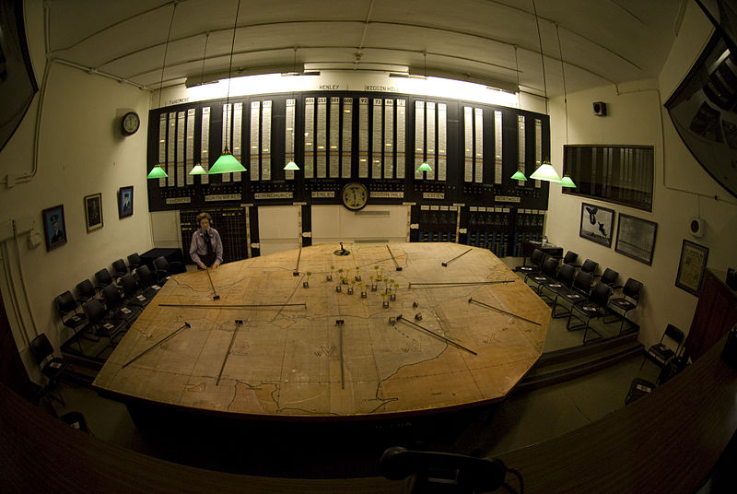 | 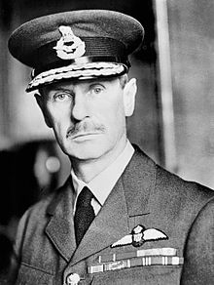
Plotting Table, 11 Group, RAF Uxbridge, ACM Sir Hugh Dowding, GCB
