Thursday, 13 December 2012
26:05 Volume 21 Number 5
Published by WW II History Round Table
Edited by Dr. Connie Harris
www.mn-ww2roundtable.org

Welcome to the December meeting of the Dr. Harold C. Deutsch World War II History Round Table. Tonight, John Nelson Rickard, author of Advance and Destroy, speaks on the “Relief of Bastogne; Patton as a Commander in the Battle of the Bulge. Veterans of the winter operations by Third US Army to relieve Bastogne will join Mr. Rickard in discussing this campaign.

Tonight’s program deals with two comingled subjects. One is the Third Army’s movement in relief of the forces (101st Airborne, CCB 10th Armored) besieged at the critical highway junction of Bastogne. The other is the leadership provided by George Smith Patton in that key operational move.

Drawing on the Third Army’s after action report for December 1944, we have a summary of the 90° northward shift of TUSA’s axis of advance, both of combat divisions and supporting troops, with rapid movement over icy roads covered in snow during the coldest winter in European memory to that point (one of the coldest on record). This enormous and immensely complicated operation was done – at least at the regimental and company level – without written orders from higher commands. 1LT Earl Hall (B/1/1303 EGSR) claimed the entire movement was on Verbal Orders only – with specific times for the regiment to enter and clear each crossroads junction – or pull off the road entirely and wait. (The first Operational Directive was 1 page, the second 1.5 pages long.)

Patton’s G2 (Col. Oscar Koch) collected information on German actions and (as possible, intentions) both in TUSA’s area of operations and also all along the front. Days before the German attack became a SHAEF concern, he was aware of it and briefed Patton. As the German drive continued, Koch and Patton became convinced that they should have plans to ride to the rescue of First Army’s beleaguered men. G-3 (Col. Halley Maddox), began drawing up army and corps level plans, and lower unit tasking plans as Eisenhower, Bradley, and Montgomery met outside Verdun on 19 December. When Patton was asked if he could shift his axis of advance and ride to the rescue, he replied affirmatively. When asked how long it would take to begin the shift, he replied within 48 hours, but some units were already beginning to shift their axis of advance northwards.

By 21 December, Bastogne was surrounded. Most medical supplies and personnel were captured, and inside the perimeter, food was scarce, and artillery ammunition severely limited; morale and will to resist were high. BG Anthony McAuliffe (101st Artillery commander, commanding in Gavin’s absence) rejected the German demand to surrender his forces with the famous – and to the Germans utterly confusing – “NUTS!”

Weather conditions improved, starting on 23 December, allowing aerial operations over the battlefield. German supply depots were attacked, and ground units began receiving close air support. German advance units had out run their supply lines, and air attacks made movement of supplies hazardous. On 25 December, XLVII Panzer Corps began a series of sequential assaults on the west side of the perimeter; the operation failed, and all tanks that broached the American perimeter were destroyed.

Major combat units, artillery and tank destroyer battalions, and engineers moved north, followed by other support units. XIX Tactical Air Command provided aerial cover as weather permitted. Patton was so confident or desperate that he used the 1303 EGSR as his right flank guard in part of Luxembourg.

The spearhead of 4th Armored Division – company D, 37th Armored Battalion broke through to Bastogne on 26 December, ending the siege. Additional units of Third Army followed. The planned counteroffensive to destroy the German Salient in Allied lines was delayed by Montgomery delayed until 3 January when First US Army (temporarily attached to his 21st Army Group) and Third Army began operations to cut off the German salient. On 1 January, the Germans launched Operation NORDWIND, a major offensive against the Seventh US Army. Due to the slow speed of advance once the offensive launched, the Germans were able to execute a fighting withdrawal from the pocket, although fuel shortages forced them to abandon most of their armor and motorized equipment.

Third Army’s December 1944 After Action Report summarizes part of the movement:
On the morning of 22 December, after days of continual rain, III Corps attacked north toward BASTOGNE (L55). On the following day, with the weather hanging to clear and cold with flurries of snow, XII Corps joined in the attack. This abrupt change in the weather was favorable to -the air-tank combination. The first attack was to relieve the besieged forces which were surrounded in BASTOGNE (P55), and by 26 December contact was regained with these units after an historic drive by the 4th Armored Division

Few army commanders encouraged their G2s to keep a wary eye on the entire front, most were concerned with their area of operations. Most would not dream of trying a major operation on largely verbal orders. Patton could and did, because he trusted his subordinates to deliver. As Hall recalls, Patton roared up, sirens blaring, to a bridge site, and ordered Hall to have the bridge done in hours. Hall carefully explained to Patton that they would have the bridge done several hours later, and why. Satisfied that the job was being done right, and the situation was understood, Patton roared off, later sending a signed photograph as commendation.

Patton was egotistical, temperamental, and failed to comprehend the political aspects of generalship. He was the best combat commander the American army had – not merely as a tactician and master of the operational arts, but as a strategist as well. Carlo D’Este flatly stated that Patton had “a genius of war,” able to both visualize an operation and to clearly communicate that vision to his staff, who despite Omar Bradley’s condescension, was probably the most effective commander-staff team in the US Army in 1944-1945. Patton also could motivation men and build esprît du corps. He provided clear statements of his intent to his staff and subordinate commands; his staff issued clear orders, and his subordinate commanders executed those orders effectively.

Further Reading:
John Nelson Rickard, Advance and Destroy; Patton as a Commander in the Bulge (U. Kentucky Press, 2011)
John Nelson Rickard, Patton At Bay: The Lorraine Campaign, 1944 (Potomac Books, 2004)
Harry Yeide, Fighting Patton: George S.Patton Jr. Through the Eyes of his Enemies (Zenith Press, 2011)
Carlo E’Este, Patton: A Genius for War (Harper, 1996)
Martin Blumenson, Patton: The Man Behind the Legend, 1885-1945 (Morrow Paperbacks, 1994)
Jerry D. Morelock, Generals of the Ardennes: American Leadership in the Battle of the Bulge (Military Bookshop, 2010)
Joseph C. Ftzharris, ed. Patton’s Fighting Bridge Builders; Company B of the 1303rd Engineer General Service Regiment (Texas A&M Press, 2007)
Announcements:
Twin Cities Civil War Round Table -
Dec. 18, 2012 MHS Civil War 150 Exhibit www.tccwrt.com - info @ tccwrt.com
St Croix Valley Civil War Round Table - Jan. 28, 2013 3rd MN at Wood Lake- Steve Anderson - 715-386-1268 – rossandhaines@comcast.net
Rochester WWII History Round Table –507-280-9970; www.ww2roundtable-rochester.org
Fort Snelling Civil War Symposium 13 April 2013, http://www.tccwrt.com/symposium.html or tccwrt@yahoo.com
Minnesota Military Museum, Camp Ripley, 15000 Hwy 115, Little Falls, MN 56345, 320-616-6050, http://www.mnmilitarymuseum.org/
Air Show - Eden Prairie - July, 13-14, 2013; http://www.airexpo-mn.org/ - 952-746-6100
Honor Flight - Jerry Kyser - crazyjerry45@hotmail - 651-338-2717
CAF - Commemorative Air Force - www.cafmn.org or Bill at 952-201-8400
Minnesota Air Guard Museum - www.mnangmuseum.org 612-713-2523
Friends of Ft. Snelling, www.fortsnelling.com
Fagen Museum in Granite Falls, www.fagenfighterswwiimuseum.org. 320-564-6644
World War II Weekend, Historic Fort Snelling, 8-9 June 2013, ftnselling@mnhs.org
Civil War Weekend, Historic Fort Snelling, 17-18 August 2013, ftnselling@mnhs.org

Round Table Schedule 2013
10 Jan. Defeat in the East 1943 (Eastern Front)
14 Feb. Emergence of Viet-Nam from WW2
14 Mar. Military Intelligence Language School
28 Mar. WW2 in the Middle East
11 Apr. Hitler’s Breakwater Fighting in the Baltic
9 May Kampfgruppe Peiper at Malmedy
If you are a veteran, or know a veteran, of one of these campaigns – contact Don Patton at cell 612-867-5144 or coldpatton@yahoo.com
HAPPY HOLIDAYS!!!
SEE YOU NEXT YEAR!!!
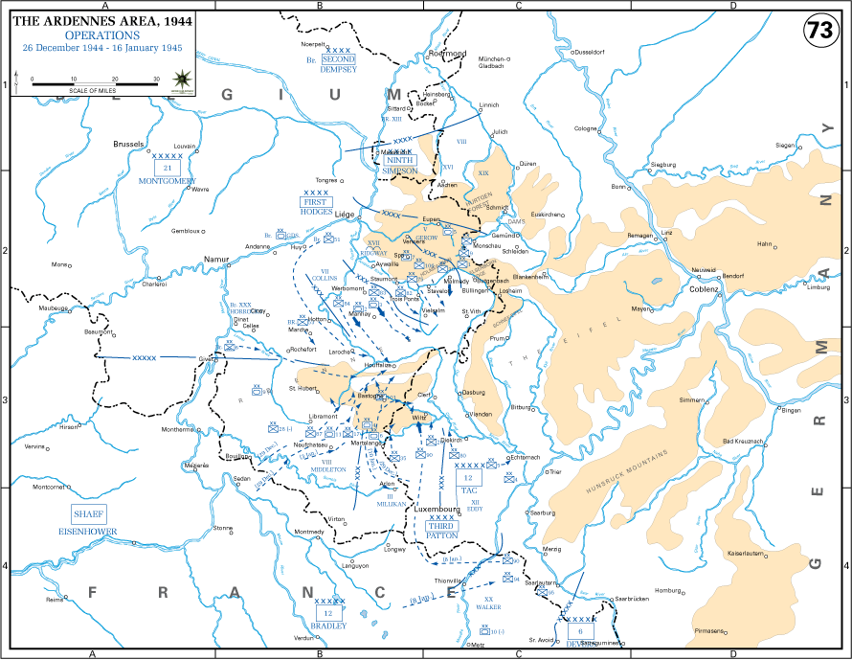
USMA History Department Map Atlas online
Cf. Jack Flowers, “Patton, Third Army, and Operational Maneuver, SAMS, USA CGSC, Ft. Leavenworth, 1998. http://www.dtic.mil/cgi-bin/GetTRDoc?AD=ADA356976
Third US Army after action report, December 1944, http://cgsc.contentdm.oclc.org/cdm/singleitem/collection/p4013coll8/id/2902/rec/9

